

INTERDEPARTMENTAL POSTGRADUATE PROGRAM OF STUDIES IN MEDICAL PHYSICS – RADIATION PHYSICS

MSc Thesis
DEVELOPMENT OF A DIGITAL EDUCATIONAL APPLICATION IN RADIATION PROTECTION FOR NON-RADIATION HEALTH CARE WORKERS

Georgia Markou

Supervisor: George Panayiotakis, Emeritus Professor
Patras, 2026



ΔΙΑΤΜΗΜΑΤΙΚΟ ΜΕΤΑΠΤΥΧΙΑΚΟ ΠΡΟΓΡΑΜΜΑ ΣΠΟΥΔΩΝ ΣΤΗΝ ΙΑΤΡΙΚΗ ΦΥΣΙΚΗ – ΑΚΤΙΝΟΦΥΣΙΚΗ

Μεταπτυχιακή Διπλωματική Εργασία
ΑΝΑΠΤΥΞΗ ΨΗΦΙΑΚΗΣ ΕΚΠΑΙΔΕΥΤΙΚΗΣ ΕΦΑΡΜΟΓΗΣ ΣΤΗΝ ΑΚΤΙΝΟΠΡΟΣΤΑΣΙΑ ΓΙΑ ΕΡΓΑΖΟΜΕΝΟΥΣ ΣΤΟ ΧΩΡΟ ΥΓΕΙΑΣ ΕΚΤΟΣ ΙΟΝΙΖΟΥΣΩΝ ΑΚΤΙΝΟΒΟΛΙΩΝ

Γεωργία Μάρκου

Επιβλέπων: Γεώργιος Παναγιωτάκης, Ομότιμος Καθηγητής
Πάτρα, 2026

University of Patras, School of Medicine
Georgia Markou
© 2026 – All rights reserved

SUPERVISOR
George Panayiotakis, Emeritus Professor (University of Patras)

EXAMINING COMMITTEE
George Panayiotakis, Emeritus Professor (University of Patras)
George Sakellaropoulos, Professor (University of Patras)
Pola (Kalliopi) Platoni, Assistant Professor (National and Kapodistrian University of Athens)

CONTENTS
CONTENTS v
ΑCKNOWLEDGEMENTS vii
ABSTRACT viii
ΠΕΡΙΛΗΨΗ ix
ACRONYMS x
Introduction 1
MODULE 1: Basic Physics of Ionizing Radiation 3
1.1 Electromagnetic and Particulate Radiation 3
1.2 Atomic Structure 5
1.3 Radioactivity 8
MODULE 2: Interactions of Ionizing Radiation with Matter 13
2.1 Classification of Radiation 13
2.2 Interactions of High-Energy Photons with Matter 14
2.3 Interactions of Energetic Charged Particles with Matter 17
2.4 Penetrating Power 18
2.5 Quantities and Units 19
MODULE 3: Radiobiology and Biological Effects of Ionizing Radiation 21
3.1 The Cell 21
3.2 Sources of Ionizing Radiation 23
3.3 Radiation Effects on Biological Systems 25
3.4 Factors Affecting Radiation Damage 29
3.5 Deterministic and Stochastic Effects 30
3.6 Fetal Irradiation 32
MODULE 4: Principles and System of Radiation Protection 33
4.1 The System of Radiation Protection 33
4.2 Types and Categories of Exposure 34
4.3 Fundamental Principles of Radiation Protection 35
4.4 Quantities and Units of Radiation Protection 36
4.5 Dose Limits 36
MODULE 5: Practical Radiation Protection in Medical Applications 38
5.1 General Radiation Protection Measures 38
5.2 Diagnostic Radiology and Image-Guided Interventional Procedures 40
5.3 Nuclear Medicine 45
5.4 Radiotherapy 50
References 53
QUESTIONS (16-20/3) 59
MODULE 1 59
MODULE 2 64
MODULE 3 68
MODULE 4 68
MODULE 5 68
Μετάφραση (21-23/3) 72

ΑCKNOWLEDGEMENTS

ABSTRACT

ΠΕΡΙΛΗΨΗ

ACRONYMS

EEAE | Greek Atomic Energy Commission
LET | linear energy transfer
UNSCEAR | United Nations Scientific Committee on the Effects of Atomic Radiation
CT | Computed Tomography
RPO | Radiation Protection Officer

Introduction

The use of ionizing radiation (X-rays, gamma rays, and particulate radiation) in medical applications represents a significant and steadily increasing source of radiation exposure worldwide. Adequate education and training in radiation protection are legally mandated for occupationally exposed workers and are essential for ensuring safety and regulatory compliance.
Over the past decade, asynchronous e-learning programs have been increasingly adopted in professional education. Their flexibility and accessibility make them valuable tools, particularly for healthcare workers with demanding schedules. Research has demonstrated that such programs are at least as effective as traditional instructional methods in improving knowledge and competence among healthcare personnel (Aryee et al., 2024; Charmchi et al., 2025; Panda & Parashar, 2022; Sinclair et al., 2016).
This educational application has been developed for non-radiation healthcare workers, such as ward nurses, emergency department and operating room staff, paramedics, and auxiliary personnel, who are not typically required to undergo radiation protection education and training, as they are not expected to be occupationally exposed to ionizing radiation. However, under certain circumstances, exposure may occur, for example, during the use of portable X-ray units in emergency departments or intensive care units, during the urgent care of patients who have been administered radiopharmaceuticals, in the absence of patient caregivers (comforters and carers), or as a result of accidental exposure.
In such situations, on-site guidance is generally provided by a professional trained in radiation protection. Nevertheless, prior education in the basic principles of radiation protection is beneficial, as it enhances both individual safety and the overall effectiveness of healthcare delivery (European Commission, 2014; International Atomic Energy Agency [IAEA], 2005; International Commission on Radiological Protection [ICRP], 2013, 2019).
The education and training of personnel who are not directly involved in the use of ionizing radiation, but who support practices involving such radiation, are required under applicable radiation protection regulations. The responsibility for ensuring the provision of such education and training lies with the organization responsible for the practice. Training may be provided internally by the designated medical physicist at the commencement of employment in the relevant field and should be repeated at regular intervals or whenever deemed necessary. This application may also serve as a refresher tool, reinforcing the fundamental principles of radiation protection among this category of personnel (Council of the European Union, 2013; Joint Ministerial Decision 45872/2019, 2019; Joint Ministerial Decision 32083/2022, 2022; Presidential Decree 101/2018, 2018).
The contents of this educational application is based on the guidelines of the Greek Atomic Energy Commission (EEAE, 2023) for the education of occupationally exposed workers (non-medical personnel), adapted to meet the objectives of this application. The material is organized into five modules, each of which can be studied independently within a short time frame and is followed by a corresponding self-assessment test. Additionally, a comprehensive self-assessment test combining questions from all five modules is available. The tests draw questions randomly from a question bank, ensuring variability and reinforcement of learning. The application also provides the option of language selection between English and Greek, thereby enhancing accessibility for a broader audience.

MODULE 1: Basic Physics of Ionizing Radiation
From a radiation protection perspective, understanding the biological effects induced by ionizing radiation requires basic knowledge of atomic and nuclear structure, as well as the nature of electromagnetic radiation and radioactivity. This module provides a concise overview of these fundamental concepts.

1.1 Electromagnetic and Particulate Radiation
Radiation may be defined as the emission and propagation of energy through space or a medium, either in the form of electromagnetic waves or particles. Depending on the mode of energy transfer, radiation is classified as either particulate or electromagnetic.
Particulate radiation consists of ions and subatomic particles, such as electrons, positrons, protons, and neutrons.
Electromagnetic radiation consists of oscillating electric and magnetic fields that are perpendicular to each other and to the direction of propagation. These oscillations occur in phase. Electromagnetic waves are characterized by their wavelength (λ) and frequency (ν). The wavelength is the distance between identical points on successive cycles, while the frequency represents the number of oscillations per unit time.
The speed of electromagnetic radiation is equal to the product of its frequency and wavelength and depends on the properties of the medium through which it propagates. In a vacuum, all electromagnetic waves travel at the same constant speed (the speed of light), independent of frequency.

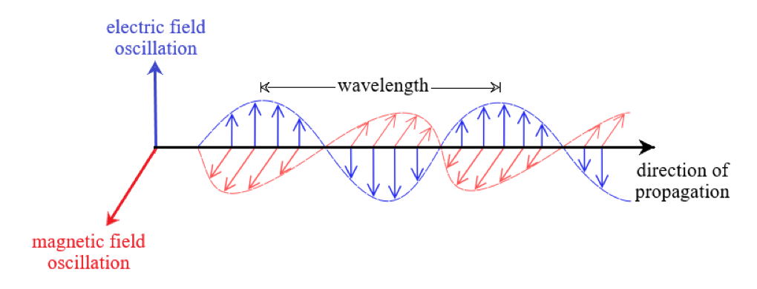
Figure 1
A diagram of electric and magnetic fields in an electromagnetic wave. Adapted from “Onde electromagnetique.svg” by SuperManu (2007), Wikimedia Commons. Licensed under CC BY-SA 3.0.

When electromagnetic radiation interacts with matter, it behaves as discrete packets of energy known as photons. The energy (E) of a photon is proportional to its frequency and is given by:
E = hν
where h is Planck’s constant.
The electromagnetic spectrum classifies radiation according to frequency (or wavelength) and energy. It spans a wide range, from low-energy radio waves to high-energy X-rays and gamma rays, and includes microwaves, infrared radiation, visible light, and ultraviolet radiation. X-rays and gamma rays are particularly important in radiation protection because their energies are sufficient to ionize matter, break molecular bonds, and damage genetic material (Hosny et al., 2017; Ng & Dance, 2014).

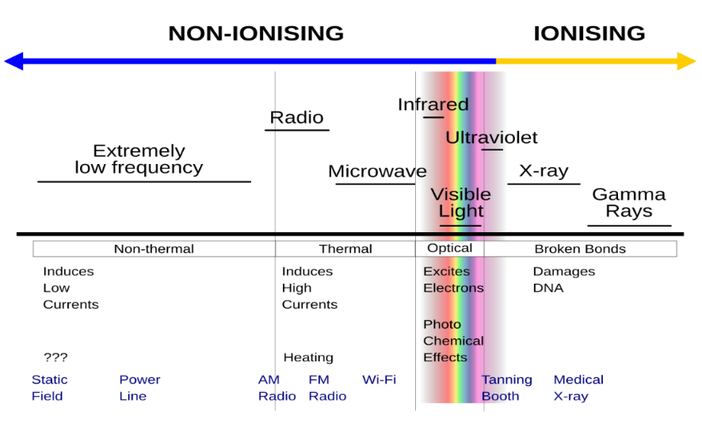
Figure 2
The electromagnetic spectrum. From “EM‑spectrum.svg” by Spazturtle (2015), Wikimedia Commons. Licensed under CC BY‑SA 4.0.

1.2 Atomic Structure
The Rutherford–Bohr model provides a simplified representation of atomic structure suitable for understanding radiation physics. In this model, an atom consists of a dense, positively charged nucleus surrounded by negatively charged electrons.
The nucleus is composed of protons and neutrons, while electrons occupy discrete circular orbits (shells) under the influence of electrostatic (Coulomb) forces. These shells are labeled K, L, M, and so on, starting from the innermost region.
Each shell corresponds to a specific energy level and can accommodate a limited number of electrons. The energy of electrons occupying a shell increases with increasing distance from the nucleus. Electrons in the outermost shell, known as valence electrons, are responsible for the formation of chemical bonds.

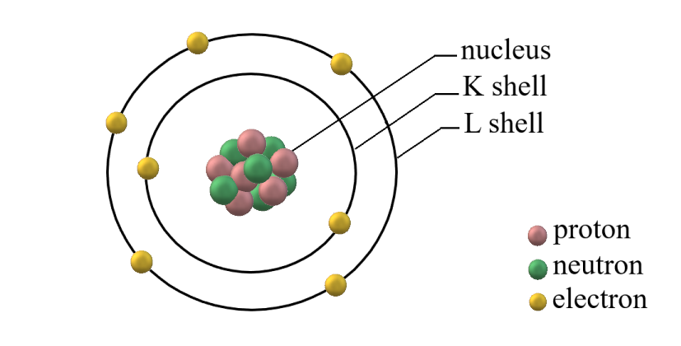
Figure 3
Rutherford–Bohr model of an atom.

Atoms normally exist in their ground state, in which electrons occupy the lowest available energy levels.
The binding energy of an electron is the energy required to remove it from its shell to an infinite distance from the atom. Binding energy decreases with increasing distance from the nucleus and increases with the number of protons (Cherry et al., 2012; Podgoršak et al., 2014).

1.2.1 Atomic Excitation and Ionization
When an atom absorbs energy, an electron may transition to a higher energy level, provided that the absorbed energy is equal to the energy difference between the two levels. The atom is then in an excited state. Because the excited state is unstable, the electron quickly returns to a lower energy level, emitting the excess energy as a photon. The energy of the emitted photon is characteristic of the element and the shells involved; therefore, the emitted radiation is referred to as characteristic radiation. When the photon energy lies within the X-ray range, it is termed characteristic X-ray emission.

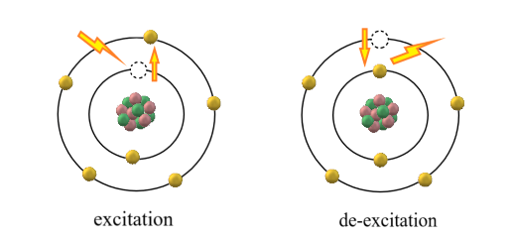
Figure 4
Excitation and de-excitation of an atom.

If the energy imparted to the atom is sufficiently high, an electron may be completely removed from the electric field of the nucleus, leaving the atom positively charged. This process is known as ionization, and the atom is said to be ionized. The vacancy created in an inner-shell is filled by an electron from a higher energy level, leading to the emission of characteristic radiation. The minimum energy required to ionize an atom is referred to as the ionization energy or ionization potential.

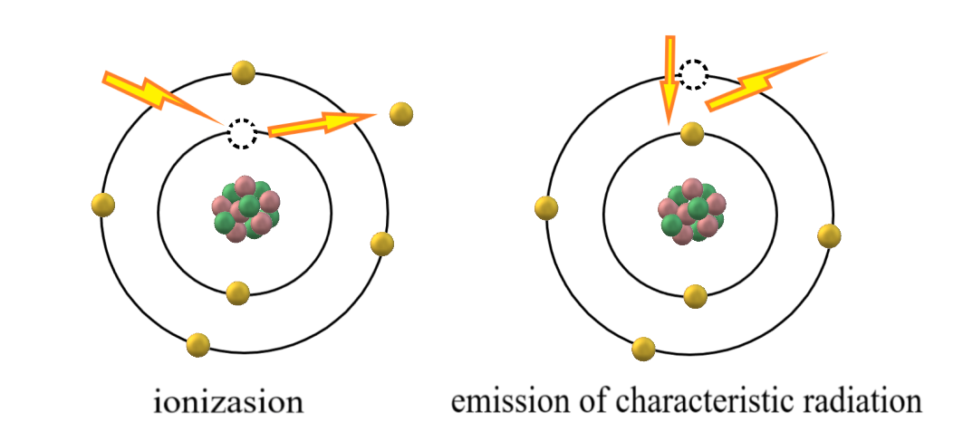
Figure 5
Ionization and emission of characteristic radiation.

As an alternative to the production of characteristic radiation, the energy released when an electron from a higher energy level fills an inner-shell vacancy may be transferred to another electron, which is subsequently ejected from the atom. The ejected electron is referred to as an Auger electron.
Ionization and excitation are the primary mechanisms through which radiation deposits energy in matter. In biological tissue, these processes initiate the sequence of events leading to cellular damage (Cember & Johnson, 2009; Cherry et al., 2012).

1.2.2 Nuclear Structure
The nucleus is composed of protons and neutrons, collectively known as nucleons. Protons carry a positive charge, while neutrons are electrically neutral, resulting in a net positive nuclear charge.
The atomic number (Z) represents the number of protons in the nucleus and determines the chemical identity of the element. The mass number (A) is the total number of nucleons. In a neutral atom, the number of electrons equals the number of protons.
Nucleons are held together by the strong nuclear force, which overcomes the electrostatic repulsion between positively charged protons.
The shell model of the nucleus proposes that protons and neutrons move in complex ways under nuclear forces. According to this model, nucleons occupy specific allowed “orbits,” similar to how electrons occupy allowed orbits around the nucleus. The most stable configuration is the ground state, while higher-energy configurations correspond to excited or metastable states. Excited states exist for extremely short times, whereas metastable states may persist significantly longer by nuclear standards, often up to hours (Cherry et al., 2012; Podgoršak, 2016).
Nuclei that have the same number of protons but differ in the number of neutrons are classified as isotopes. A nuclide is a nuclear species characterized by its specific nuclear composition (A and Z) and the arrangement of nucleons within the nucleus. Metastable forms are treated as distinct nuclides and are referred to as nuclear isomers (Cember & Johnson, 2009; Cherry et al., 2012).

1.2.3 Nuclear Stability
Not all arrangements of protons and neutrons result in stable nuclei. Observations of naturally occurring elements show that stable nuclei cluster around a so-called “line of stability,” which reflects the most favorable neutron-to-proton ratios. For lighter elements, stability occurs when the number of neutrons is approximately equal to the number of protons. Heavier nuclei require a higher proportion of neutrons (approximately 50% more) to remain stable.
Another important indicator of stability is the binding energy per nucleon. Higher values indicate stronger nuclear cohesion and greater stability. This value reaches a maximum near mass number 60 and decreases for heavier nuclei, reflecting the increasing instability associated with large atomic masses (Cherry et al., 2012).

1.3 Radioactivity
Radioactivity (or radioactive decay) is a spontaneous process in which an unstable parent nucleus transforms into a more stable configuration through the emission of particles or electromagnetic radiation. The resulting daughter nucleus may itself be unstable and continue to decay until stability is achieved.
A radioactive substance containing atoms with the same nuclear structure is referred to as a radioactive nuclide or radionuclide. Radioactive nuclides may occur naturally or be artificially produced through nuclear reactions.
Several types of radioactive decay exist, depending on the characteristics of the nuclide. The decay modes of greatest relevance to medical physics are alpha decay, beta decay, and gamma emission (Podgoršak, 2016).

1.3.1 Alpha Decay
In alpha (α) decay, an unstable parent nucleus transforms into a more stable daughter nucleus by emitting an energetic alpha particle. The alpha particle is a helium nucleus consisting of two protons and two neutrons. As a result of this emission, the atomic number (Z) of the parent nucleus decreases by two, and the mass number (A) decreases by four.

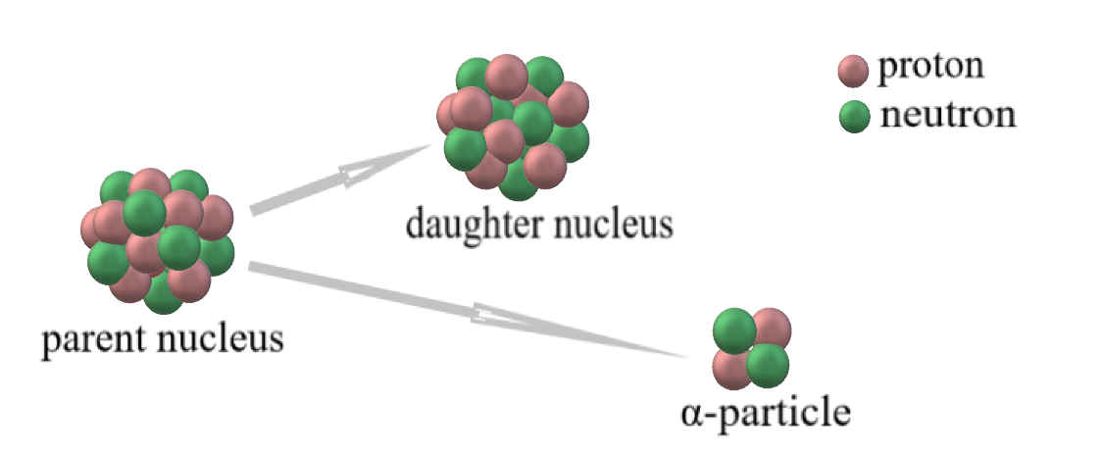
Figure 6
Alpha decay.

As the α particle travels through matter, it interacts strongly with surrounding atoms, losing energy rapidly through ionization and excitation processes. After losing its kinetic energy, it captures two electrons from the surrounding medium and becomes a neutral helium atom. The daughter atom, initially left with an excess of electrons relative to its nuclear charge, subsequently releases these electrons and returns to a neutral state (Podgoršak, 2016).

1.3.2 Beta Decay
Three processes fall into the category of beta (β) decay: beta minus (β⁻) decay, beta plus (β⁺) decay, and electron capture.

1.3.2.1 Beta minus Decay
In beta minus decay, a neutron-rich parent nucleus converts one of its neutrons into a proton and emits an electron (beta particle) along with an electron antineutrino. As a result, the atomic number of the daughter nucleus increases by one, while the mass number remains unchanged. This process occurs because the nucleus seeks a more stable neutron-to-proton ratio.

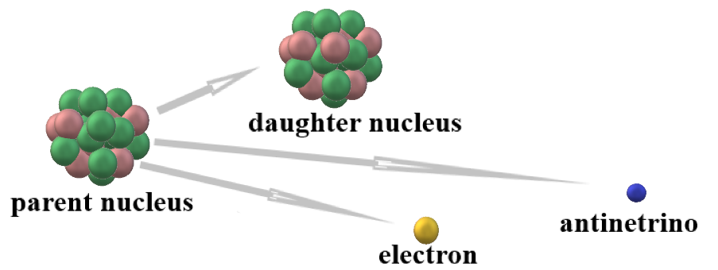
Figure 7
Beta minus decay.

Antineutrinos (and neutrinos) are electrically neutral particles with extremely small mass and interact very weakly with matter (Podgoršak et al., 2014).

1.3.2.2 Beta Plus Decay
In beta plus decay, a proton-rich parent nucleus converts one of its protons into a neutron and emits a positron (a positively charged electron) along with an electron neutrino. As a result, the atomic number decreases by one, while the mass number remains unchanged.

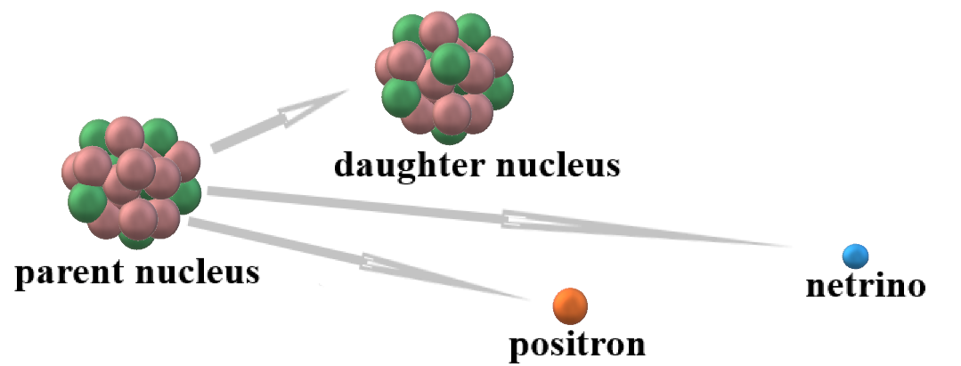
Figure 8
Beta plus decay.

The emitted positron gradually loses its kinetic energy and eventually annihilates with an electron, producing two gamma photons of 511 keV energy, which are emitted in nearly opposite directions. This process forms the basis of positron emission tomography (PET) (Podgoršak et al., 2014).

1.3.2.3 Electron Capture
Electron capture occurs when an inner-shell electron (usually from the K or L shell) is absorbed by the nucleus. The electron combines with a proton to form a neutron, and a neutrino is emitted. As a result, the atomic number decreases by one, while the mass number remains unchanged. The created vacancy is filled by an electron from a higher energy level, resulting in the emission of characteristic X-rays and/or Auger electrons (Cherry et al., 2012).

1.3.3 Gamma Decay and Internal Conversion
Alpha and beta decay often leave the daughter nucleus in an excited state. The nucleus returns to its ground state through one of two processes.
The first process is gamma (γ) decay, in which the excess nuclear energy is emitted in the form of one or more photons. These photons are called gamma rays (γ-rays) to indicate their nuclear origin. The energy of the emitted photon corresponds to the difference between two nuclear energy states (Podgoršak, 2016).

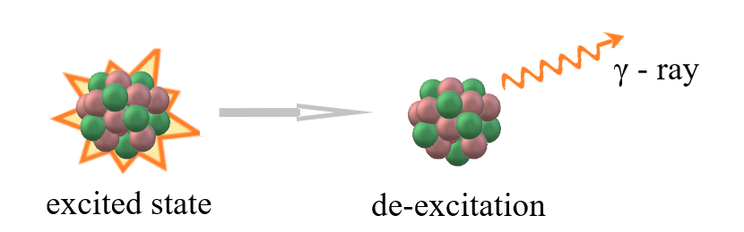
Figure 9
Gamma decay.

The second process is internal conversion, in which the excited nucleus transfers its excess energy directly to an electron (typically from the K shell). This electron is then ejected from the atom. The resulting vacancy is filled by an electron from a higher energy level, producing characteristic X-rays and/or Auger electrons (Podgoršak et al., 2014).
In most alpha and beta decay events, gamma emission or internal conversion occurs almost instantaneously. However, in some cases, the nucleus remains in a metastable state and de-excites after a measurable delay (Podgoršak, 2016).

1.3.4 Activity
Activity (A) is a quantity used to describe the intensity of a radioactive source. It is defined as the rate at which radioactive nuclei decay in a given sample.
The unit of activity is the becquerel (Bq), where:
1 Bq = 1 decay per second
In medical applications, activity levels are typically much higher and are commonly expressed in megabecquerels (MBq) or gigabecquerels (GBq), corresponding to millions or billions of decays per second.
Activity is directly related to the number of radioactive atoms present in a sample: the greater the number of unstable nuclei, the higher the activity (Cherry et al., 2012; Podgoršak, 2016).

1.3.4.1 Exponential Law of Radioactive Decay
Radioactive decay is a random process at the level of individual atoms but follows a predictable pattern when large numbers of atoms are considered.
The exponential law of radioactive decay describes how the number of radioactive nuclei decreases over time:
According to this relation, the number of nuclei N(t) at time t is equal to the initial number of nuclei, N₀, multiplied by the exponential factor e^{-λt}, which describes the characteristic exponential decrease of radioactive decay. The decay constant (λ) represents the probability per unit time that a nucleus will decay and is characteristic of each radionuclide (Cherry et al., 2012).
The half-life (t_{1/2}) is the time required for half of the radioactive nuclei in a sample to decay.
For example, technetium-99m, which is widely used in nuclear medicine, has a half-life of approximately 6 hours. This means that if initially the number of radioactive nuclei is N₀, then:
- after 6 hours → 50% of N₀ remain
- after 12 hours → 25% of N₀ remain
Half-life is an important concept in radiation protection because it determines how long a radioactive substance remains hazardous.

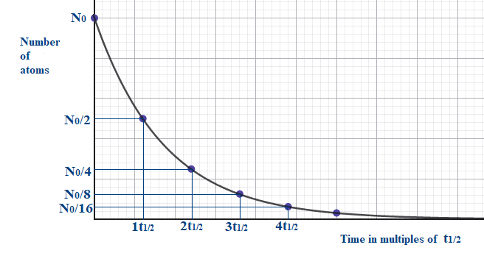
Figure 10
Graph of the exponential law of radioactive decay.

Half-lives are characteristic properties of radioactive nuclides and vary widely, from fractions of a second to millions of years.

MODULE 2: Interactions of Ionizing Radiation with Matter
This module introduces the fundamental properties of ionizing radiation, including its classification, interactions with matter, energy deposition mechanisms, and attenuation. These concepts form the physical basis for understanding radiation dose, biological effects, and the radiation protection principles discussed in subsequent modules.

2.1 Classification of Radiation
Depending on its ability to ionize matter, radiation is classified as either ionizing or non-ionizing.
Non-ionizing radiation has energy lower than the ionization potential of atoms or molecules and therefore cannot remove electrons from them. Examples include radio waves, microwaves, and visible light.
Ionizing radiation has sufficient energy to remove electrons from atoms or molecules, producing ionization. It is further classified as directly ionizing or indirectly ionizing, depending on how energy is transferred to matter (Podgoršak, 2016).

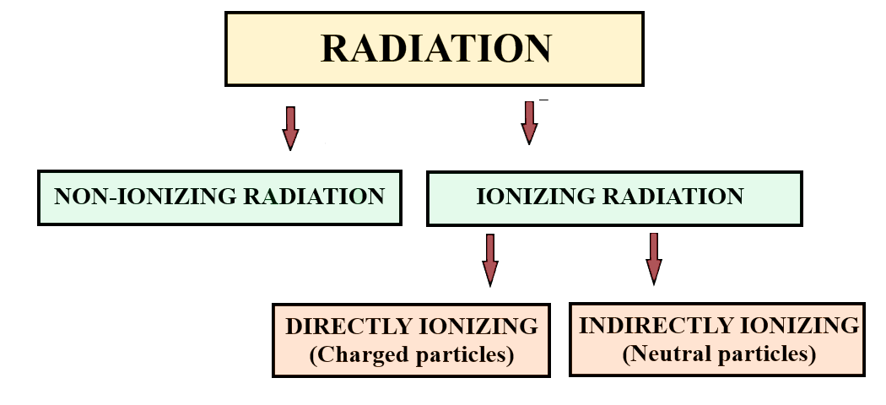
Figure 11
Classification of radiation.

Directly ionizing radiation consists of charged particles, such as electrons, protons, alpha particles, and heavy ions. These particles deposit energy directly in matter through Coulomb interactions with atoms along their path.
Indirectly ionizing radiation consists of neutral particles, such as photons (X-rays and gamma rays) and neutrons. These particles do not ionize matter directly. Instead, they first transfer energy to charged particles (such as electrons or positrons), which then deposit energy in matter through direct interactions (Maqbool, 2017; Podgoršak, 2016).

2.2 Interactions of High-Energy Photons with Matter
When high-energy photons pass through matter, they may either pass through without interaction or interact with atoms and transfer part or all of their energy.
The interactions may result in:
- Scattering, where the photon changes direction and transfers part of its energy
- Absorption, where the photon transfers all its energy and disappears
In both cases, when energy is transferred to electrons, these electrons can produce ionizations and excitations in the material. A single energetic electron may produce hundreds or thousands of secondary ionizations (Cherry et al., 2012; Huda, 2010).
The interaction of a photon with matter is a probabilistic process, meaning that there is no certainty that an interaction will occur at a given point. Instead, only the probability of interaction can be described.
Although several types of photon-matter interactions exist, four are of particular importance in medical physics: coherent (Rayleigh) scattering, Compton scattering, the photoelectric effect, and pair production.
Each type of photon–matter interaction has a probability of occurrence that depends on the energy of the photon and the properties of the absorbing material, particularly its density and atomic number (Cherry et al., 2012; Podgoršak, 2016).

2.2.1 Coherent (Rayleigh) Scattering
In coherent scattering, a low-energy photon interacts with the atom as a whole. The photon is scattered with essentially no loss of energy but changes direction by a small angle.
For the photon energies typically used in medical procedures, this type of interaction is relatively rare and contributes negligibly to radiation dose (Huda, 2010; Podgoršak, 2016).
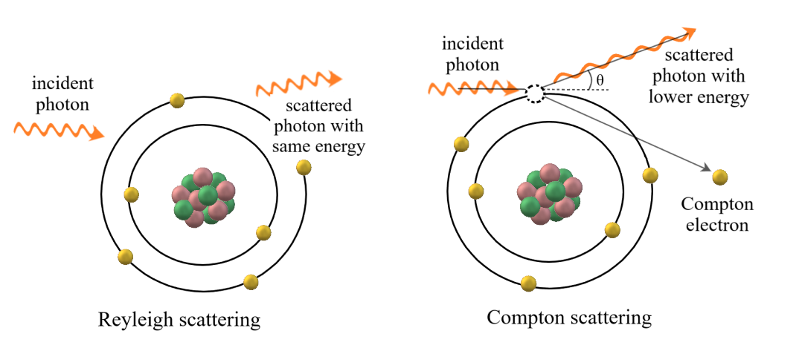
Figure 12
Rayleigh and Compton scattering.

2.2.2 Compton Scattering
In Compton scattering, the incident photon interacts with a loosely bound outer-shell electron. Part of the photon’s energy is transferred to the electron, which is ejected from the atom as a Compton electron, while the photon is deflected and continues with reduced energy.
The amount of energy transferred depends on the scattering angle: small angles result in low energy transfer, whereas large angles result in higher energy transfer. The ejected electron subsequently loses its energy through excitation and ionization processes in the material, while the scattered photon may undergo further interactions.
Compton scattering is a major contributor to occupational exposure due to scattered radiation (Cherry et al., 2012; Huda, 2010).

2.2.3 Photoelectric Effect
In the photoelectric effect, an incident photon interacts with a tightly bound inner-shell electron and is completely absorbed, resulting in the ejection of the electron, known as a photoelectron.
For this interaction to occur, the photon energy must exceed the binding energy of the electron. The resulting vacancy in the inner shell is subsequently filled by an electron from a higher energy level, leading to the emission of characteristic X-rays or Auger electrons (Cherry et al., 2012; Huda, 2010).

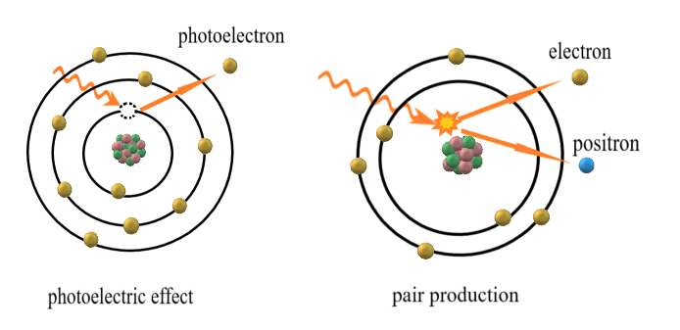
Figure 13
Photoelectric effect and pair production.

2.2.4 Pair Production
Pair production occurs when a high-energy photon interacts with the electric field of a nucleus. The photon is completely absorbed, and its energy is converted into an electron-positron pair.
This process can occur only if the photon energy exceeds 1.022 MeV, which corresponds to the combined rest mass energy of the electron and positron. The excess energy is shared as kinetic energy between the two particles.
After losing its kinetic energy through excitation and ionization, the positron annihilates with an electron, producing two gamma photons emitted in approximately opposite directions.
Pair production becomes important at high photon energies and is an example of mass-energy equivalence (Cherry et al., 2012; Podgoršak, 2016).

2.2.5 Exponential Attenuation Law
At the macroscopic level, when a beam of photons passes through a material, its intensity decreases progressively due to interactions with the atoms of the medium. Each photon is characterized by a certain probability of interaction, and as the beam penetrates deeper into the material, the number of photons decreases.
For a narrow, monoenergetic photon beam of initial intensity I₀ transmitted through a homogeneous material, attenuation is described by the exponential attenuation law (Beer-Lambert law):
I(x) = Io e^{-μx}
where I(x) is the beam intensity after passing through a material of thickness x.
The linear attenuation coefficient (μ) represents the probability per unit distance that a photon will undergo any type of interaction with the material. It depends on the photon energy as well as on the density and atomic number of the material.
A useful concept is the half-value layer (HVL), defined as the thickness of a material required to reduce the beam intensity to one half of its initial value. For example:
- 1 HVL → reduces intensity to 50%
- 2 HVL → reduces intensity to 25%
The HVL is widely used in radiation protection and shielding design, as it provides a simple and practical measure of how effectively a material attenuates radiation (Cherry et al., 2012; Podgoršak, 2016).

2.3 Interactions of Energetic Charged Particles with Matter
When an energetic charged particle travels through matter, it loses energy and slows down through multiple interactions with atoms in the medium. These interactions, governed by Coulomb forces with orbital electrons and nuclei, result in gradual energy loss and occasional changes in direction. Because each interaction transfers only a small amount of energy, the particle undergoes many interactions before coming to rest.
These interactions are referred to as collisions and are classified as either elastic or inelastic (Baeyens et al., 2023; Podgoršak, 2016).
In elastic collisions, the charged particle interacts with an atom or nucleus, primarily changing direction, with only a small transfer of energy.
In inelastic collisions, part of the particle’s kinetic energy is transferred to the medium. Depending on the proximity of the interaction, these collisions are classified into three types:
- Hard (close) collisions: These occur when the particle passes very close to an orbital electron, transferring a relatively large amount of energy and causing its ejection. The ejected electron may produce further ionizations and is referred to as a delta (δ) ray. Such collisions are relatively infrequent but involve significant energy transfer.
- Soft (distant) collisions: These occur when the particle passes at a greater distance from the atom, transferring only a small amount of energy. They may cause excitation or ionization, typically involving outer-shell electrons. Although each interaction involves only a small energy transfer, such collisions are very numerous and account for a large fraction of the total energy loss.
- Radiative collisions: These occur mainly when light-charged particles (such as electrons or positrons) interact with the Coulomb field of the nucleus and undergo deceleration. In this case, part of their energy is emitted as X-ray photons, known as bremsstrahlung (Baeyens et al., 2023; Cherry et al., 2012; Podgoršak, 2016).
Heavy charged particles, such as alpha particles and protons, lose their energy primarily through numerous inelastic collisions, transferring only a small fraction of their energy in each interaction. Because of their relatively large mass, they are only slightly deflected. As a result, they follow short, nearly straight paths and produce dense ionization along their tracks.
Light charged particles are more easily deflected due to their low mass. They may lose a large fraction of their energy in single interactions and can be scattered through large angles. Consequently, their paths are irregular (tortuous), and their range is less predictable (Cherry et al., 2012).
For charged particles, the range is defined as the average distance a particle travels in a given medium before coming to rest.

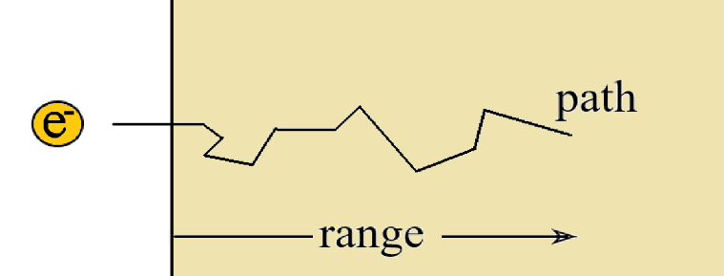
Figure 14
Electron path versus range.

2.4 Penetrating Power
The penetrating power of ionizing radiation refers to its ability to pass through matter without being completely absorbed. It depends on the type of radiation, as well as its energy, mass, and electric charge, and on the properties of the absorbing material, such as density and atomic number. In general, electromagnetic radiation with higher photon energy and particulate radiation with lower mass and electric charge exhibit greater penetrating power.
Alpha particles have a relatively large mass and a double positive charge, which result in strong interactions with matter and rapid energy loss. Consequently, they exhibit very low penetrating power. Their range in air is typically on the order of a few centimeters, and they can be stopped by a sheet of paper or the outer layer of human skin.
Alpha radiation can be highly hazardous if alpha-emitting substances are inhaled, ingested, or enter the body through wounds.
Beta particles (electrons and positrons) have a much lower mass and carry a single electric charge, which allows them to penetrate further than alpha particles. Their range in air may reach several meters, while in solid materials it is typically limited to a few millimeters.
Beta radiation can penetrate the skin to the germinal layer and may cause skin injury with prolonged exposure. Internal exposure to beta-emitting radionuclides can also pose significant health risks.
Gamma rays and X-rays are highly penetrating and can pass through significant thicknesses of matter. Unlike charged particles, they do not have a finite range and are attenuated exponentially as they pass through matter. They can penetrate even substantial thicknesses of materials, including the human body (Cherry et al., 2012; Podgoršak et al., 2014; United Nations Environment Programme, 2016; U.S. Department of Energy, 2012).

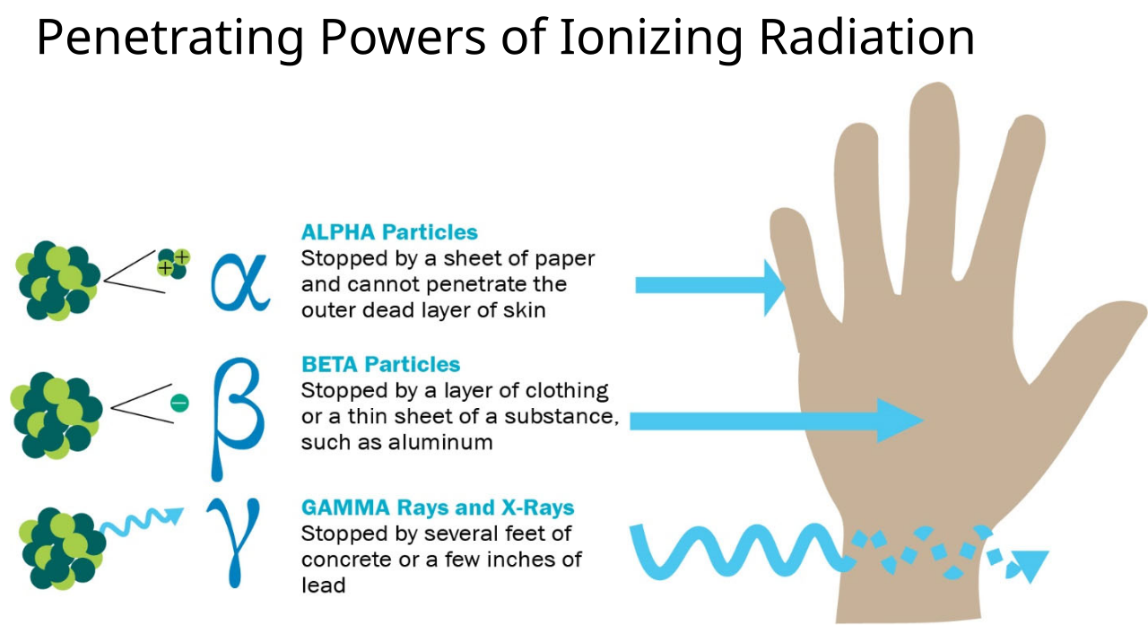
Figure 15
Penetrating powers of ionizing radiation. From Penetrating powers of ionizing radiation image, by U.S. Environmental Protection Agency (2018). Public Domain.

2.5 Quantities and Units
To quantify the energy deposited by ionizing radiation in a material, such as biological tissue, the quantity absorbed dose (or simply dose) is used. It is defined as the ratio of the mean energy imparted to a material to its mass. The unit of absorbed dose is the gray (Gy).
The biological effects of radiation depend not only on the absorbed dose but also on the rate at which energy is deposited. Dose rate is a related quantity, defined as the absorbed dose delivered per unit time. It is commonly expressed in units of gray per hour (Gy·h⁻¹).
Another important quantity is linear energy transfer (LET), which describes how densely energy is deposited along the path of radiation. LET is defined as the average energy transferred per unit length of the radiation track.
Radiation can be broadly classified based on LET:
- Low-LET radiation, such as X-rays and gamma rays, produces sparsely distributed ionizations along its path
- High-LET radiation, such as protons and heavy ions, produces dense ionization along short tracks
High-LET radiation generally produces more complex and less repairable biological damage compared with low-LET radiation (Baeyens et al., 2023).

MODULE 3: Radiobiology and Biological Effects of Ionizing Radiation
Radiobiology is the scientific field that studies the effects of ionizing radiation on biological systems at the molecular, cellular, tissue, and organism levels. It examines how radiation interacts with biological matter, how cells respond to and repair damage, and the resulting biological consequences. Radiobiology integrates principles of radiation physics with cellular and molecular biology.

3.1 The Cell
The cell is the fundamental structural and functional unit of living organisms. Eukaryotic cells are composed of three main components: the cell membrane, the cytoplasm, and the nucleus.
The cytoplasm is a gel-like substance composed primarily of water, proteins, sugars, and salts. It contains organelles such as ribosomes, which are responsible for protein synthesis, and mitochondria, which play a key role in energy production. It also includes the cytoskeleton, a network of protein fibers that maintains cell shape and facilitates intracellular transport. The cytoplasm is the site of numerous metabolic processes essential for cellular function.
The cell membrane separates the cell from its external environment and regulates the exchange of substances and signals.
The nucleus is a membrane-bound organelle that contains the genetic material in the form of deoxyribonucleic acid (DNA), which carries the information required for most cellular processes (Alberts et al., 2013).

3.1.1 DNA Structure
DNA is a large molecule composed of two antiparallel strands forming a double helix. Each strand consists of repeating units called nucleotides, which include a sugar, a phosphate group, and a nitrogenous base. The nucleotides are linked by phosphodiester bonds, forming the backbone of the DNA molecule.
The four bases, adenine, thymine, cytosine, and guanine, pair in a complementary manner, with adenine pairing with thymine and cytosine pairing with guanine. The two strands are held together by hydrogen bonds between these complementary bases.

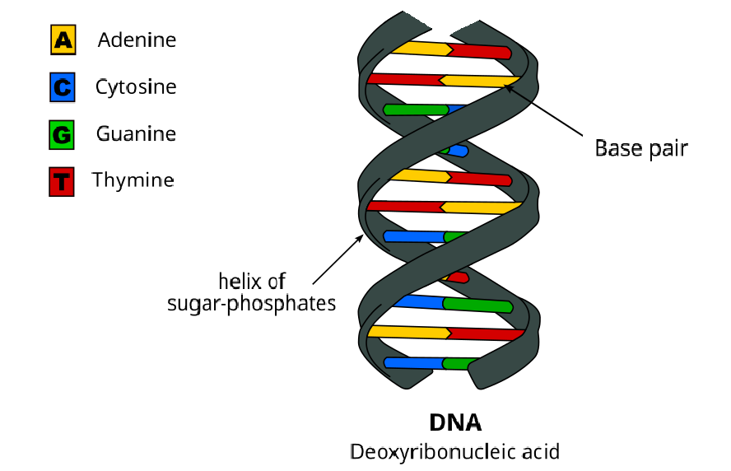
Figure 16
DNA double helix. Adapted from “DNA base flipping” by Magladem96 (2014), Wikimedia Commons. Licensed under CC BY-SA 3.0.

In the nucleus, DNA is organized as chromatin, a complex of DNA and proteins (histones). During cell division, chromatin condenses to form chromosomes (Reindl et al., 2023; Alberts et al., 2013).

3.1.2 Types of Cells
Human cells are classified as either somatic cells or germ cells. Somatic cells divide by mitosis, producing two genetically identical daughter cells, whereas germ cells divide by meiosis, producing reproductive cells with half the genetic material.
Somatic cells may also be described according to their level of differentiation. Stem cells are undifferentiated and capable of self-renewal and differentiation. Transit (amplifying) cells are partially differentiated and divide a limited number of times, while mature cells are fully differentiated and perform specific functions within tissues. Cells that divide rapidly and are less differentiated tend to be more radiosensitive (Suntharalingam et al., 2005).

3.1.3 Cell Cycle
The cell cycle consists of two main phases: the M phase and interphase. The M phase includes mitosis, during which the nucleus divides, followed by cytokinesis, resulting in the formation of two daughter cells. Interphase is the period between divisions, during which the cell grows, performs its functions, and prepares for division.
Interphase is subdivided into three stages: G1, S, and G2. During G1, the cell grows and synthesizes proteins; during the S phase, DNA replication occurs; and during G2, the cell continues to grow and prepares for mitosis.

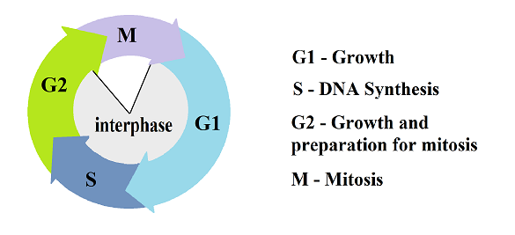
Figure 17
Phases of cell cycle.

Cells possess regulatory checkpoints that monitor internal conditions and DNA integrity before allowing progression to the next phase. If DNA damage occurs, for example due to ionizing radiation, the cell cycle may be temporarily halted to allow repair. If the damage is too extensive, the cell may undergo programmed cell death (Alberts et al., 2013).

3.2 Sources of Ionizing Radiation
Human beings are continuously exposed to low levels of ionizing radiation from both natural and artificial sources. Natural sources have always been present in the environment, whereas artificial sources have been introduced through human activities. With the increasing use of ionizing radiation in medicine, industry, and research, radiation protection has become essential (UNSCEAR, 2008).

3.2.1 Natural Background Radiation
Natural background radiation arises from several sources and constitutes the largest contribution to the average annual radiation exposure of the population, accounting for approximately 80% of total exposure. These sources are commonly categorized as terrestrial radiation, inhalation, ingestion, and cosmic radiation (UNSCEAR, 2008).
Terrestrial radiation originates from naturally occurring radionuclides in the Earth’s crust, primarily uranium-238, thorium-232, and potassium-40, along with their decay products. Their concentrations vary depending on local geology, resulting in geographical differences in exposure. These radionuclides may also be present in building materials, contributing to indoor exposure.
Inhalation exposure is mainly associated with radioactive gases such as radon-222 and thoron-220, produced from the decay of uranium and thorium in soil and rocks. Radon is the most significant contributor to natural radiation exposure. While it is diluted in outdoor air, it can accumulate indoors, especially in poorly ventilated spaces.
Ingestion of radionuclides occurs through food and water. Naturally occurring radionuclides are taken up by plants and enter the food chain. Radionuclides such as carbon-14 and potassium-40 are naturally present in the human body and contribute to internal exposure.
Cosmic radiation originates from outer space and consists of high-energy particles and electromagnetic radiation. When it interacts with the Earth’s atmosphere, secondary radiation is produced. The atmosphere provides significant shielding; therefore, radiation levels increase with altitude and are higher at aircraft cruising altitudes (UNSCEAR, 2008; Baeyens et al., 2023).

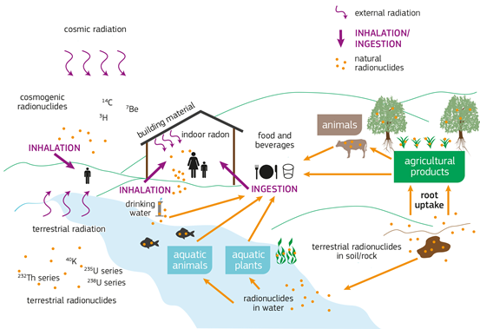
Figure 18
Simplified pathways of natural radionuclides. From Joint Research Centre, European Commission. Licensed under CC BY 4.0.

3.2.2 Artificial Radiation Sources
Artificial sources of ionizing radiation arise from human activities and contribute approximately 20% of the average annual radiation exposure. These include medical applications, nuclear power generation, industrial and research uses, and, to a lesser extent, nuclear accidents and past atmospheric nuclear testing (UNSCEAR, 2008).
Among these, medical exposure represents by far the largest contribution. Ionizing radiation is widely used in diagnostic imaging and therapy, with doses varying depending on the type and complexity of the procedure. Medical exposure is not evenly distributed across the population, as some individuals may undergo repeated or high-dose procedures. In developed healthcare systems, the average dose from medical exposure may approach or even equal that from natural background radiation (UNSCEAR, 2008; Baeyens et al., 2023).

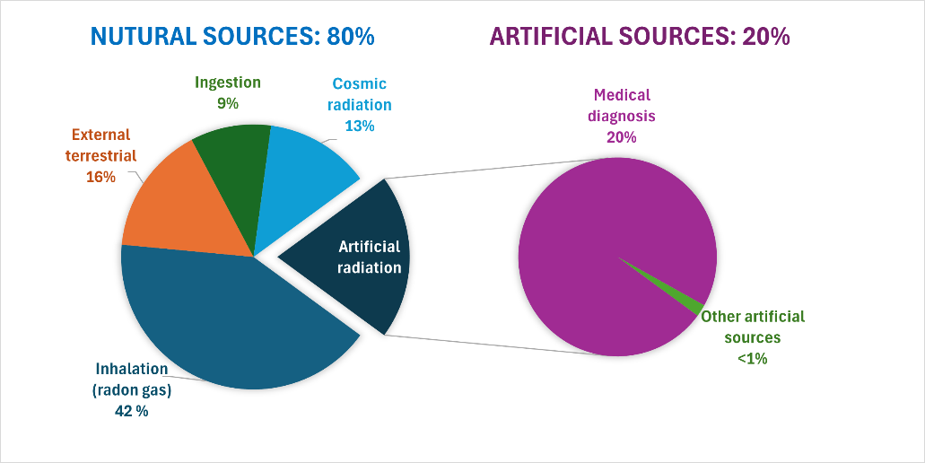
Figure 19
Worldwide average annual human exposure to ionizing radiation. Data retrieved from Sources and effects of ionizing radiation (UNSCEAR, 2008).

3.3 Radiation Effects on Biological Systems
Ionizing radiation interacts with biological tissue primarily by transferring energy to atoms and molecules, causing ionization and excitation. These initial physical events occur within extremely short time scales and initiate a sequence of chemical and biological processes that may ultimately result in cellular damage.

3.3.1 Direct and Indirect Action
Ionizing radiation can damage critical biomolecules, particularly DNA, through two main mechanisms: direct action and indirect action.
In direct action, radiation deposits energy directly in a critical biological molecule, such as DNA, causing ionization or excitation of its atoms. This may result in the breaking of chemical bonds and the formation of free radicals within the molecule itself.
Free radicals are ions, atoms or molecules with one or more unpaired electrons, making them highly reactive and chemically unstable. When formed within DNA, they can alter its molecular structure and impair its function. Direct action is the predominant mechanism for high-LET radiation, which deposits energy densely along its track (Baeyens et al., 2023; IAEA, 2010).
In indirect action, radiation interacts with molecules other than critical targets in the cell, most importantly water, which constitutes the majority of cellular content. This interaction leads to the formation of free radicals that can diffuse over short distances and react with critical biomolecules, including DNA, proteins, and lipids, causing damage. Indirect action is the predominant mechanism for low-LET radiation.
The process of indirect action in water, known as water radiolysis, can be described in four phases:
- Physical phase: Energy is deposited in water molecules, causing ionization and excitation
- Physicochemical phase: Formation of free radicals
- Chemical phase: Free radicals diffuse and interact with nearby biomolecules, inducing structural damage
- Biological phase: The chemical damage is expressed as biological effects such as DNA damage, cellular dysfunction, or cell death
The biological phase may extend from minutes to years, depending on cellular conditions and repair processes (Baeyens et al., 2023; IAEA, 2010).

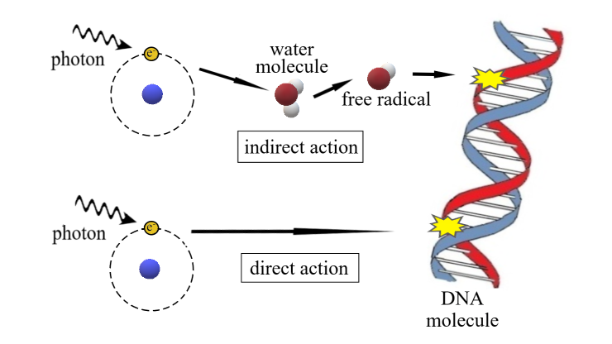
Figure 20
Difference between direct and indirect damage to cellular DNA.

3.3.2 DNA Damage
Although ionizing radiation can damage all cellular components, DNA is considered the most critical target because it carries the genetic information required for cell survival and replication.
DNA lesions include base alterations, single- and double-strand breaks, DNA cross-links, and complex DNA damage:
- Base lesions: Modification or loss of DNA bases, which may alter the genetic code; in some cases, a base may be completely removed, forming an abasic site
- Single-strand breaks (SSBs): Breaks affecting one DNA strand; these are relatively common and usually repaired efficiently
- Double-strand breaks (DSBs): Breaks affecting both DNA strands in close proximity; these are the most severe lesions and are strongly associated with cell death, mutations, and carcinogenesis
- DNA cross-links: Bonds formed within the same strand (intrastrand), between strands (interstrand), or between DNA and proteins, interfering with replication and transcription
- Clustered DNA damage: Multiple closely spaced lesions within a short DNA segment, which are particularly difficult to repair (Reindl et al., 2023; Wondergem, 2014).

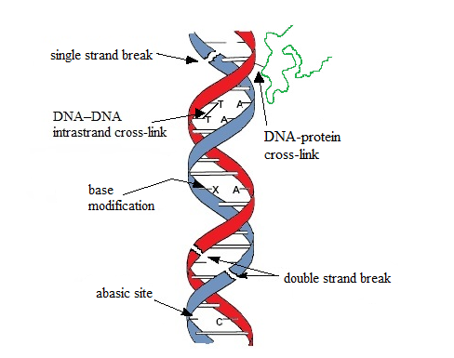
Figure 21
Types of DNA damage. Adapted from Morissette (2007), Wikimedia Commons. Public domain.

3.3.3 DNA Repair and Cellular Response to Ionizing Radiation
Exposure to ionizing radiation can induce a large number of DNA lesions. However, cells possess efficient repair mechanisms, involving specialized enzymatic pathways, that detect and repair most of this damage. Only a small fraction of radiation-induced DNA damage remains unrepaired or is repaired incorrectly, leading to biological consequences (Dale & Wondergem, 2014; Wondergem, 2014).
Three main outcomes of DNA damage can be distinguished: accurate repair, cell death, and misrepair.
When DNA damage is repaired accurately, the original genetic information is restored, and the cell continues to function normally. Such cells retain their ability to divide and are referred to as clonogenic cells (Suntharalingam et al., 2005).
Conversely, when the damage is extensive or repair mechanisms fail, the cell loses its functionality and/or its ability to divide, resulting in cell death. In non-proliferating cells, cell death is associated with the loss of metabolic activity, whereas in proliferating cells it is defined as the loss of reproductive capacity.
Pathways of cell death include:
- Apoptosis: A regulated, programmed process in which the cell eliminates itself in response to severe damage; common in radiosensitive tissues
- Necrosis: An unregulated form of cell death resulting from severe damage to cellular structures, often associated with inflammation
- Mitotic catastrophe: Cell death occurring after defective mitosis due to unrepaired DNA damage
Cellular senescence represents a non-lethal outcome characterized by permanent growth arrest, in which cells remain metabolically active but are no longer capable of proliferation (Joiner, 2009; Reindl et al., 2023; Wondergem, 2014).
When DNA damage is repaired incorrectly (misrepair), the cell survives but carries permanent genetic alterations, such as mutations or chromosomal aberrations. These changes may be transmitted to daughter cells, leading to genomic instability and increasing the risk of cancer development. This outcome is particularly important in proliferating cells, such as stem cells or germ cells (Suntharalingam et al., 2005).

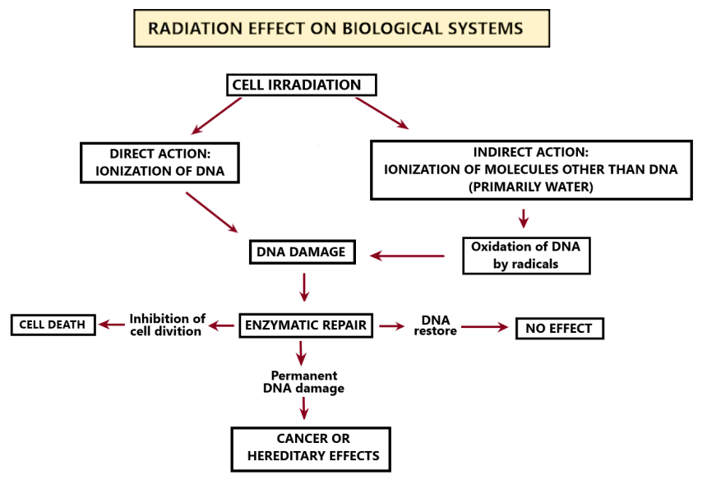
Εικόνα 22
Effects of ionizing radiation on DNA and its consequences.

3.4 Factors Affecting Radiation Damage
The extent of biological damage caused by ionizing radiation depends on a variety of physical and biological factors. These include the radiation dose and dose rate, the type of radiation, the characteristics of the exposed cells, as well as individual factors such as age and overall health status.
- Higher doses result in more extensive cellular damage and a greater probability of biological effects
- At low dose rates, cells have enough time to repair damage between successive energy deposition events. In contrast, at high dose rates, energy is delivered over a short period, allowing damage to accumulate more rapidly and increasing the likelihood of severe and complex lesions
- Low-LET radiation produces sparsely distributed ionizations and primarily simpler, more easily repairable DNA damage, whereas high-LET radiation produces dense ionization and complex, less easily repairable damage, with an increased likelihood of cell death or mutations
- Cells are more radiosensitive during the G2 and M phases of the cell cycle. In contrast, they exhibit greater resistance during the G1 phase and particularly during the late S phase, partly due to active DNA synthesis and more efficient DNA repair mechanisms
- Cells that divide rapidly and are less differentiated, such as stem cells, germ cells, and hematopoietic cells, are generally more radiosensitive. In contrast, highly differentiated cells with little or no capacity for division, such as neurons and muscle cells, are more radioresistant. Cells with intermediate characteristics, such as epithelial and endothelial cells, show moderate radiosensitivity
- Children are more radiosensitive than adults due to higher rates of cell division and a longer expected lifespan, which increases the likelihood that radiation-induced effects may develop over time (Baeyens et al., 2023; Cherry, 2012; Saha, 2019)

3.5 Deterministic and Stochastic Effects
Exposure to ionizing radiation can result in a range of biological effects. These effects are classified as somatic when they occur in the exposed individual, or hereditary when they affect future generations through damage to germ cells. Somatic effects are further divided into deterministic and stochastic effects, while hereditary effects are considered stochastic in nature (Wondergem, 2014).

3.5.1 Deterministic Effects
Deterministic effects, or tissue reactions, occur only when the absorbed dose exceeds a defined threshold, below which no clinically detectable effects are observed. Above this threshold, the severity of the effects increases with increasing dose. These effects are associated with the loss of a large number of cells, particularly stem cells, resulting in impaired tissue function when the tissue’s repair capacity is exceeded. Their manifestation may occur over a time span ranging from hours to years following exposure (Baeyens et al., 2023; Wondergem, 2014).
A characteristic example is the acute radiation syndrome (ARS), which occurs following high-dose, whole-body or near whole-body exposure, typically above ~1 Gy. ARS develops in stages:
- Prodromal phase: Early symptoms such as nausea, vomiting, and fatigue
- Latent phase: Temporary improvement of symptoms despite ongoing damage
- Manifest illness phase: Clinical effects depending on dose, including:
  - Hematopoietic syndrome: bone marrow suppression, infections, bleeding
  - Gastrointestinal syndrome: severe diarrhea, dehydration, sepsis
  - Central nervous system syndrome: at very high doses, leading to rapid deterioration and death
Recovery depends on the survival of stem cells and the effectiveness of medical care.
Deterministic effects may also result from localized exposure. Examples include skin reactions (erythema, epilation, necrosis), cataract formation, temporary or permanent sterility and late tissue effects such as fibrosis or organ dysfunction (Baeyens et al., 2023; Saha, 2019).

3.5.2 Stochastic Effects
Stochastic effects do not have a threshold, and their occurrence is probabilistic. The probability of occurrence increases with dose, but the severity of the effect is independent of the dose. These effects typically appear long after exposure (Wondergem, 2014).
The primary stochastic effect is cancer. Radiation-induced cancer arises from genetic alterations that lead to uncontrolled cellular proliferation. The risk of its occurrence increases with dose and is influenced by various factors, such as individual susceptibility and environmental conditions.
Because cancer has many possible causes, radiation exposure cannot usually be identified as the direct cause in an individual case. Instead, radiation effects are evaluated by observing increased cancer incidence in exposed populations compared with baseline levels. Current epidemiological evidence suggests that an increased cancer risk can be reliably detected at doses of approximately 0.1 Gy or higher (Baeyens et al., 2023; IAEA, 2010).
Hereditary effects arise from radiation-induced damage to the DNA of germ cells (sperm or ova), which may be transmitted to offspring. Although such effects have been demonstrated in experimental animals, there is currently no conclusive evidence of increased hereditary effects in human populations exposed to ionizing radiation (Baeyens et al., 2023; UNSCEAR, 2008).

3.6 Fetal Irradiation
Radiation exposure during pregnancy requires special consideration because the developing embryo and fetus are particularly radiosensitive. This increased sensitivity is due to rapid cell division, a high proportion of undifferentiated cells, and critical periods of organ development. The effects of radiation depend mainly on the absorbed dose and the stage of development at the time of exposure.
- During the pre-implantation stage (approximately 1–10 days post-conception), radiation exposure typically results in an “all-or-nothing” effect. The embryo either dies or survives without detectable damage.
- During the organogenesis period (approximately 11 days to 8 weeks post-conception), the embryo is highly radiosensitive. Exposure during this stage may result in structural abnormalities, particularly affecting the central nervous system, skeleton, and developing organs. At sufficiently high doses, these effects may lead to embryonic or neonatal death.
- During the fetal period (after approximately 8 weeks post-conception), the risk of severe structural abnormalities decreases; however, other effects may occur, such as growth retardation and functional disorders, including intellectual disability (particularly with exposure between 8 and 15 weeks), as well as an increased risk of cancer later in life (Baeyens et al., 2023; Wondergem, 2014).
These effects form the basis for the implementation of strict radiation protection measures during pregnancy, with emphasis on avoiding unnecessary exposure and applying appropriate protective measures.

MODULE 4: Principles and System of Radiation Protection
This section presents the fundamental concepts and the regulatory framework of radiation protection. It examines how risks from ionizing radiation are managed in practice through internationally established principles, regulatory frameworks, and dose limits, with the aim of protecting workers, patients, and the general public.

4.1 The System of Radiation Protection
The system of radiation protection is a structured framework of principles, regulations, and practical measures designed to protect individuals, society, and the environment from the harmful effects of ionizing radiation. By balancing potential risks against anticipated benefits, the system ensures the justified use of ionizing radiation in medicine, industry, research, and other applications. Its main goal is to prevent deterministic effects and to reduce the probability of stochastic effects to acceptable levels.
The scientific basis of radiation protection is primarily provided by the United Nations Scientific Committee on the Effects of Atomic Radiation (UNSCEAR), which evaluates data from epidemiological studies, experimental research, and environmental measurements to assess radiation risks.
Based on scientific evidence, the International Commission on Radiological Protection (ICRP) develops recommendations that define the fundamental principles of radiation protection (justification, optimization, and dose limitation) as well as key protection quantities and dose limits.
The International Atomic Energy Agency (IAEA), drawing upon the scientific findings of UNSCEAR and the recommendations of international expert bodies, particularly the ICRP, publishes the International Safety Standards. These standards support countries in establishing and maintaining effective regulatory systems.
Within the European Union, Council Directive 2013/59/Euratom establishes legally binding requirements for radiation protection.
In Greece, these requirements are incorporated into national legislation, and the Greek Atomic Energy Commission is the competent authority responsible for the regulation and supervision of radiological and nuclear safety, as well as radiation protection.
The system of radiation protection applies to all exposure situations (planned, emergency, and existing) and to all categories of exposure (occupational, medical, and public). Its effective implementation depends on the cooperation of regulatory authorities, employers, radiation protection experts, and workers (ICRP, 2007; IAEA, 2014; Council of the European Union, 2013; EEAE, n.d.).

4.2 Types and Categories of Exposure
According to ICRP Publication 103 (2007), exposure to ionizing radiation is classified in two complementary ways: into exposure situations and into exposure categories. This classification helps determine how radiation protection measures are applied in different contexts.

4.2.1 Types of Exposure Situations
Exposure situations describe how and when exposure occurs.
Planned exposure situations are those that are deliberately introduced and managed in advance. These include both anticipated exposures (normal exposures) and unanticipated exposures (potential exposures). Normal exposures include routine uses of ionizing radiation, such as diagnostic radiology, interventional procedures, radiotherapy, nuclear medicine, and industrial applications. Potential exposures may involve unintended overexposures resulting from equipment malfunction, software or hardware failure, or irradiation of the wrong patient.
Emergency exposure situations arise from unexpected events that require urgent action to reduce exposure. Examples include nuclear accidents, loss of radioactive sources, or malicious use of radioactive material.
Existing exposure situations refer to exposures that are already present when a decision is made to control them. Typical examples include natural background radiation (such as radon) and residual contamination from past nuclear events (ICRP, 2007).

4.2.2 Categories of Exposure
Exposure categories describe who is exposed.
Occupational exposure refers to radiation exposure of workers incurred as a result of their work and from situations that can reasonably be regarded as their responsibility. Healthcare workers involved in procedures using ionizing radiation are considered occupationally exposed and have specific rights and responsibilities in relation to radiological protection.
Medical exposure refers to exposure of patients undergoing diagnostic or therapeutic procedures involving ionizing radiation. In these cases, exposure is intentionally delivered for the direct health benefit of the patient. Medical exposure also includes exposure of carers and comforters, as well as participants in biomedical research.
Public exposure refers to exposure of individuals from all other sources, excluding occupational and medical exposure. This includes exposure from environmental sources or incidental presence near radiation practices.
For the purposes of radiation protection, non-radiation healthcare workers are generally considered members of the public, as their exposure is incidental and not part of their professional duties (ICRP, 2007).

4.3 Fundamental Principles of Radiation Protection
The system of radiation protection is based on three fundamental principles established by the ICRP: justification, optimization, and dose limitation. These principles provide a structured approach to ensuring that ionizing radiation is used safely and responsibly.
Justification states that any decision involving exposure to ionizing radiation should result in more benefit than harm. In practice, this means that a procedure or activity involving radiation should only be performed if it provides a clear advantage, such as improving diagnosis or treatment. This principle applies to all exposure categories, including medical, occupational, and public exposure.
Optimization of protection, commonly known as the ALARA principle (As Low As Reasonably Achievable), requires that radiation exposures be kept as low as reasonably achievable while still achieving the intended objective. This involves minimizing the radiation dose, the number of individuals exposed, and the duration and likelihood of exposure, while taking into account practical factors such as available technology, economic considerations, and clinical needs. This principle is particularly important in everyday clinical practice.
Dose limitation sets upper limits on radiation exposure for individuals in order to prevent unacceptable risks. Dose limits apply to occupational and public exposure, but not to patients undergoing medical procedures, since their exposure is justified by direct health benefits. These limits ensure that no individual is exposed to unnecessarily high levels of radiation under normal conditions (Council of the European Union, 2013; ICRP, 2007).

4.4 Quantities and Units of Radiation Protection
In radiation protection, specific quantities are used to describe the biological impact of ionizing radiation. The most basic quantity, the absorbed dose, does not fully describe the biological effect, because different types of radiation can produce different levels of damage for the same amount of deposited energy.
To account for this, the concept of equivalent dose is used. Equivalent dose takes into consideration the type of radiation, since some types (such as alpha particles) are more biologically damaging than others (such as X-rays or gamma rays). It is calculated by multiplying the absorbed dose by a radiation weighting factor, and its unit is the sievert (Sv).
In addition, different tissues and organs in the body have different sensitivities to radiation. To reflect this, the concept of effective dose is used. Effective dose combines the equivalent doses received by various tissues, each weighted according to its radiosensitivity. It provides a single value that represents the overall risk to the whole body and is also expressed in sieverts (Sv) (Baeyens et al., 2023; IAEA, 2010).

4.5 Dose Limits
Dose limits are established to protect individuals from excessive radiation exposure and to reduce the risk of harmful health effects. They are based on recommendations from the ICRP and have been incorporated into European legislation through Council Directive 2013/59/Euratom.
Dose limits apply to occupational and public exposure in planned exposure situations. They do not apply to medical exposure of patients, since these exposures are justified by clinical benefit. Dose limits are not thresholds for harm, but regulatory tools designed to control avoidable exposure and ensure that radiation risks remain low.
The dose limits for occupational and public exposure are summarized in Table 1.

Table 1. Dose limits for occupational and public exposure
Type of limit | Occupational (mSv) | Public (mSv)
Effective Dose | 20 mSv/year (averaged over 5 years, maximum 50 mSv in a single year) | 1 mSv/year
Equivalent dose in:
Lens of the eye | 20 mSv/year (averaged over 5 years, maximum 50 mSv in a single year) | 15 mSv/year
Skin | 500 mSv per year (averaged over any area of 1 cm²⁾ | 50 mSv/year (averaged over any area of 1 cm²)
Extremities (hands/feet) | 500 mSv/year | Not applicable

Pregnant workers should be employed under conditions in which the equivalent dose to the unborn child is kept as low as reasonably achievable and, in any case, does not exceed 1 mSv for the remainder of the pregnancy. Breastfeeding workers should not be employed in tasks involving a significant risk of radionuclide intake or bodily contamination (Council of the European Union, 2013).
For comparison with dose limits, indicative average values of effective dose from common medical procedures in Europe are presented below.
- Chest X-ray: ~0.1 mSv
- Mammography: ~0.3 mSv
- CT scan (chest): ~6.6
- CT scan (head): ~1.9 mSv
- CT scan (abdomen): ~11.3 mSv
- Interventional procedures: may range from a few mSv to several tens of mSv (European Commission, 2014)
Natural background radiation: ~2–3 mSv per year (UNSCEAR, 2008).

MODULE 5: Practical Radiation Protection in Medical Applications
This module presents the main medical applications of ionizing radiation and outlines the practical measures required to minimize radiation exposure in clinical settings. It focuses on situations that may be encountered by non-radiation healthcare workers and provides guidance on safe behavior in environments where radiation is used. Emphasis is placed on applying fundamental protection principles, such as time, distance, and shielding, in everyday practice, as well as on recognizing potential radiation hazards and responding appropriately.

5.1 General Radiation Protection Measures
General radiation protection measures are based on simple and effective principles that can be applied in a wide range of situations encountered by healthcare personnel. Its application principles is essential for minimizing exposure and ensuring safe working conditions in environments where ionizing radiation is used.

5.1.1 Time, Distance, and Shielding
Three fundamental strategies are used to reduce external radiation exposure: minimizing time, maximizing distance, and using appropriate shielding. The radiation dose received is directly proportional to the duration of exposure, assuming a constant dose rate; therefore, reducing the time spent near a radiation source decreases the accumulated dose.
Radiation intensity decreases with increasing distance from the source, following the inverse square law for point sources. Doubling the distance from the source reduces the exposure to approximately one quarter. Although this relationship is less exact for extended sources, increasing distance remains one of the most effective protective measures.
Shielding involves placing appropriate materials between the radiation source and the individual to reduce exposure. Its effectiveness depends on the type and energy of the radiation, as well as on the material’s thickness and atomic number. Common shielding materials include lead, steel, and concrete.
In clinical environments, the exposure of healthcare personnel is mainly due to scattered radiation rather than the primary beam. Protective measures therefore include both structural shielding (e.g., walls and barriers) and personal protective equipment, such as lead aprons, thyroid shields, protective eyewear, and gloves. Additional protective devices, including ceiling-suspended screens, table-mounted curtains, and mobile shields, are commonly used, particularly in fluoroscopy and interventional procedures (IAEA, 2018; Sutton et al., 2014).

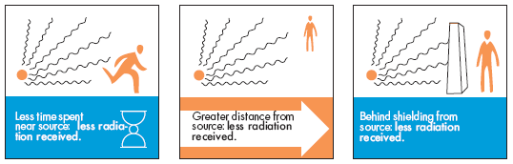
Figure 23
Principles of radiation protection: Time, distance, and shielding. From Time, distance, and shielding, by U.S. Nuclear Regulatory Commission (n.d.), NRC. Public domain.

5.1.2 Controlled and Supervised Areas
Workplaces where ionizing radiation is used are classified as controlled or supervised areas. This classification helps prevent unnecessary exposure and ensures that appropriate protection measures are applied.
A controlled area is a designated space where radiation exposure or the risk of contamination may be significant and where specific protective measures are required. Access is restricted and controlled, and personnel working in these areas must receive appropriate training and instructions. Warning signs, signals, and safety instructions are clearly displayed at entrances and within the area. Examples include X-ray rooms, radiotherapy treatment rooms, and nuclear medicine laboratories handling radioactive materials.
A supervised area is a location where radiation levels are lower but still require periodic monitoring and review. Special protective measures are generally not necessary; however, conditions are regularly assessed to ensure that exposure remains within acceptable limits. Examples include corridors, control rooms, and offices adjacent to controlled areas.
The clear identification of these areas helps prevent inadvertent entry and supports safe working practices (IAEA, 2014, 2018; Sutton et al., 2014).

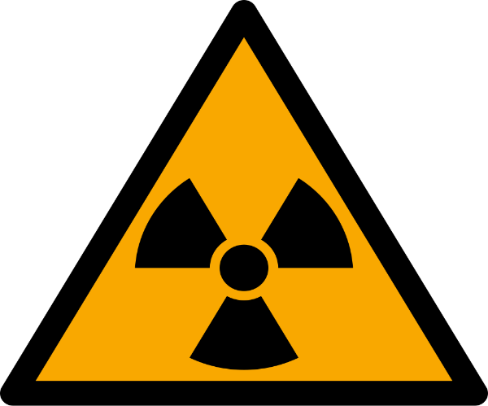
Figure 24
ISO 7010 W003 warning sign for radioactive material or ionizing radiation. From ISO 7010 W003: Radioactive material or ionizing radiation, by MaxxL (2013), Wikimedia Commons. Public domain.

5.2 Diagnostic Radiology and Image-Guided Interventional Procedures
Diagnostic radiology and image-guided interventional procedures use X-rays for imaging and, in some cases, treatment guidance. Since their discovery by Wilhelm Conrad Röntgen in 1895, X-rays have become essential in medical practice due to their ability to penetrate tissues and produce images of internal structures.

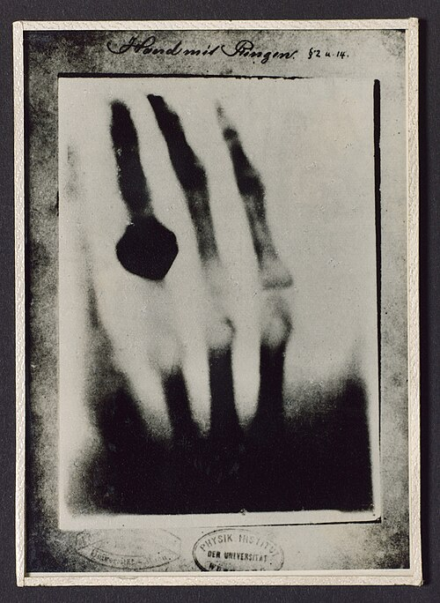
Figure 25
Photograph of the first radiograph of the hand of Anna Bertha Röntgen, taken on December 22, 1895. From Photograph of a radiograph of hand taken by Wilhelm Conrad Röntgen, by Wellcome Library (n.d.), Wikimedia Commons. CC BY 4.0.

Radiographic techniques provide static images of the body, while fluoroscopy allows real-time imaging, supporting both diagnosis and minimally invasive procedures. Common procedures of radiology include general radiography, computed tomography (CT), mammography, and interventional procedures such as angiography, stenting, and image-guided biopsy (IAEA, 2018).

5.2.1 X-ray Production
Medical images are formed based on the different attenuation properties of tissues, which depend on their density and atomic composition.
X-rays are generated in an X-ray tube, where electrons emitted from a heated cathode are accelerated toward a metal anode. When these high-energy electrons interact with the target, X-rays are produced and exit through a window to form the primary beam.
As the X-ray beam passes through the patient, some photons are absorbed, some are scattered, and some are transmitted to form the image. Scattered radiation is emitted in different directions, making the patient the main source of secondary radiation in the room. Although scattered radiation is much less intense than the primary beam, it is the main source of occupational exposure, since healthcare workers are rarely exposed directly to the primary beam.
Within the X-ray tube, X-rays are emitted in all directions; therefore, the tube is externally shielded, except for the window, to prevent radiation from spreading in unwanted directions. Nevertheless, a small fraction of high-energy photons may penetrate the protective housing, resulting in leakage radiation (Nowotny, 2014; Poletti, 2014).

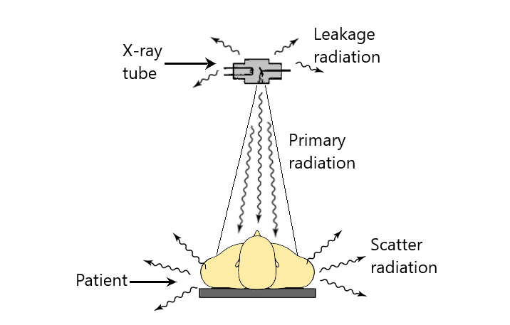
Figure 26
Primary, scattered, and leakage radiation.

5.2.2 Radiation Protection Measures in Radiography
Radiographic procedures are typically performed in dedicated X-ray rooms, where structural shielding provides adequate protection. Access to these rooms is restricted, and warning signs indicate the presence of ionizing radiation.
In certain situations, healthcare personnel may need to assist patients (e.g., elderly patients or children). In such cases, the following precautions should be observed:
- Wear appropriate protective equipment (e.g., a lead apron)
- Maintain the maximum possible distance from the X-ray beam
- Keep hands outside the primary beam
- Avoid repeated exposure of the same staff member
- Pregnancy or suspected pregnancy should be reported to the radiology department
- Follow the instructions of designated radiation protection personnel (IAEA, 2018; ICRP, 2013).


Figure 27
Radiation protection apron. From Darby X-Ray apron, by Kiran891 (2023), Wikimedia Commons. CC BY-SA 4.0.

Mobile X-ray units are often used in areas such as intensive care units, emergency departments, or wards, where structural shielding may be limited. In these situations, the following precautions should be observed:
- Personnel not required near the patient should keep as far a distance as possible
- Those who must remain should wear appropriate protective equipment
- Use mobile shielding when available
- Follow the instructions of designated radiation protection personnel (IAEA, 2018)

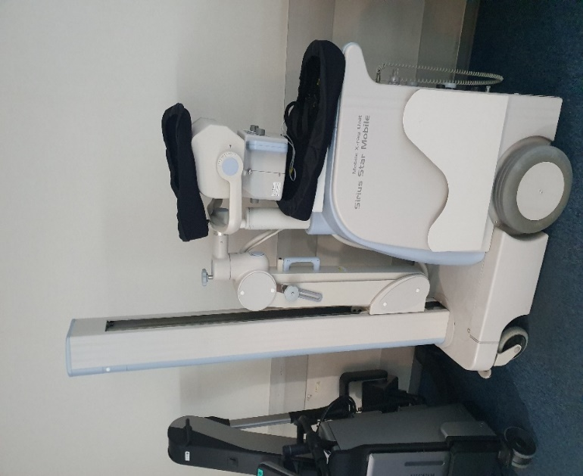
Figure 28
Mobile X-ray Unit. From Mobile X-Ray Unit Sirius Star Mobile by Syced (2022), Wikimedia Commons. CC0 1.0.

5.2.3 Radiation Protection Measures in Fluoroscopy
Fluoroscopy and image-guided interventional procedures are performed in controlled areas with restricted access, whereas mobile fluoroscopy systems (C-arms) are used in operating theatres and emergency settings.

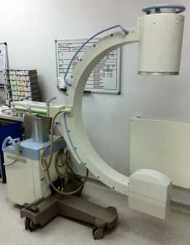
Figure 29
C-arm. From Mobile X-ray image intensifier, by Dennisthemonkeychild (2015), Wikimedia Commons. CC BY-SA 4.0.

Since staff exposure is mainly due to scattered radiation from the patient, the following measures are essential:
- Remain in the room only when necessary
- Maximize distance from the patient during exposure
- Wear protective lead aprons
- Use additional protective equipment, such as thyroid shields, protective eyewear, and gloves, when appropriate
- Never place any part of the body in the primary beam
- Personnel who are or may be pregnant should inform the responsible supervisor
- Follow the instructions of designated radiation protection personnel (IAEA, 2018; ICRP, 2013)

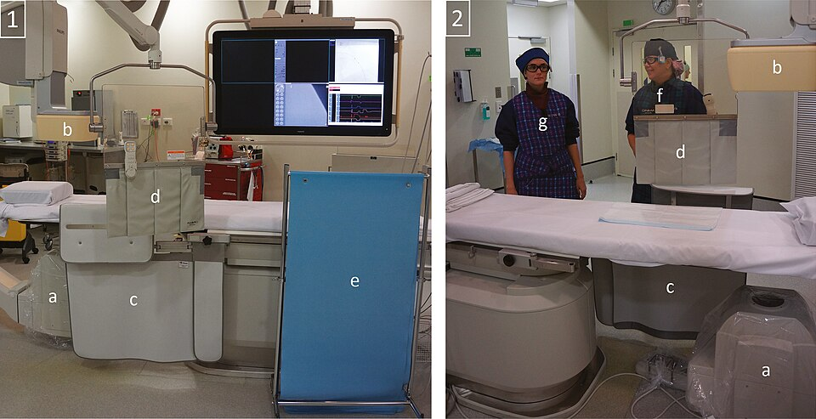
Figure 30
Lead protection and staff positioning.
1: View from the operating side; 2: View from the non‐operating side; (a) x‐ray tube; (b) X‐ray detector; (c) Table mounted lead drapes with extension panel; (d) Movable ceiling mounted lead glass shield with lead drapes; (e) Moveable stand‐alone shield; (f) Common location for fluoroscopic operator; (g) Common location for scrub nurse. From Lead protection and staff position, by K. Wilson-Stewart et al. (2018), Journal of Applied Clinical Medical Physics. CC BY 4.0.

5.3 Nuclear Medicine
Nuclear medicine is a medical specialty that uses unsealed radioactive materials, known as radiopharmaceuticals, for diagnostic and therapeutic purposes. These substances consist of radionuclides bound to pharmaceutical compounds that allow them to localize in specific organs or tissues.
Radiopharmaceuticals are typically administered via oral, intravenous, or intracavitary routes. Following administration, the patient becomes a source of radiation. These substances are excreted primarily through urine, feces, sweat, and other bodily fluids, which may become sources of contamination and radiation exposure.

5.3.1 Diagnostic Nuclear Medicine Procedures
Diagnostic procedures involve the administration of small amounts of short-lived radiopharmaceuticals, typically emitting gamma rays or positrons. The radiopharmaceutical is distributed within the patient’s body and emits radiation, which is detected to provide functional and metabolic information about organs, tissues, and physiological processes.
Radiation exposure to personnel and the public from diagnostic nuclear medicine procedures is generally low. Patients are typically discharged shortly after radiopharmaceutical administration, and only limited radiation protection instructions are required, as the administered activities result in relatively low radiation levels.
The main imaging systems used in nuclear medicine are gamma camera systems (including single-photon emission computed tomography, SPECT) and positron emission tomography (PET) (Flux & Yong, 2014; Lodge & Frey, 2014; Saha, 2019).

5.3.2 Therapeutic Nuclear Medicine Procedures
Therapeutic procedures involve the administration of higher-activity radiopharmaceuticals, often emitting beta particles that deliver radiation directly to target tissues. Beta decay may also be accompanied by the emission of gamma rays and/or characteristic X-rays, which can penetrate the body and contribute to external exposure.
These procedures are generally performed in hospital settings. Depending on the radionuclide and the administered activity, patients may remain radioactive for extended periods and may require hospitalization in dedicated isolation rooms designated as controlled areas with restricted access.
Hospitalization ensures that family members, caregivers, and the public are protected from unnecessary exposure. Once the residual activity falls below established release criteria, patients may be discharged with specific radiation protection instructions (IAEA, 2009; Saha, 2019).

5.3.3 Radiation Protection Measures in Nuclear Medicine
In nuclear medicine, exposure may occur through two main pathways:
• External exposure, originating from radioactive sources, including patients who have been administered radiopharmaceuticals
• Internal exposure (contamination), resulting from the intake of radioactive material through inhalation, ingestion, skin contamination, or absorption through wounds
When appropriate radiation protection measures are implemented, exposure to non-radiation healthcare workers is generally minimal. However, exposure may become significant under certain circumstances, such as accidental contamination events, emergency medical care, urgent surgery involving patients who have recently received therapeutic doses of radiopharmaceuticals, or patient transport (Flux & Yong, 2014; Lodge & Frey, 2014).

5.3.3.1 General Protection Principles and Safety Precautions
The principles of time, distance, and shielding apply:
- Minimize time spent near radioactive sources or patients
- Maximize distance whenever possible
- Use shielding where available
Structural shielding is effective; however, lead aprons provide limited protection against high-energy gamma emitters (e.g., iodine-131), although portable shielding may be useful. Personal protective equipment, such as gloves, gowns, eye protection, masks, and shoe covers, is important for preventing contamination.
Personnel who are or may be pregnant should avoid close contact with patients who have recently received therapeutic levels of radiopharmaceuticals.
Radiation warning signs are present in areas where radioactive materials are used, stored, or disposed of. Examples include nuclear medicine facilities, radioactive waste storage areas, and containers holding contaminated materials (Carlsson & Le Heron, 2014; Saha, 2019). The following precautions should be observed:
- Enter controlled areas only with authorization and appropriate instructions
- Follow all posted safety instructions
- Do not handle unknown or suspicious materials

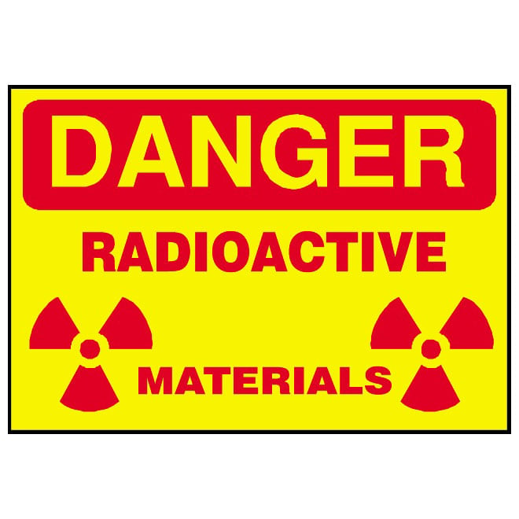
Figure 31
Radioactive materials warning symbol. From Radioactive materials warning symbol, by Vectorportal (n.d.), CC BY.

Packages used for radionuclide transport are labeled with radiation warning symbols (Saha, 2019). If such a package is found, the following actions should be taken:
- Do not open or handle the package
- Notify the nuclear medicine department immediately
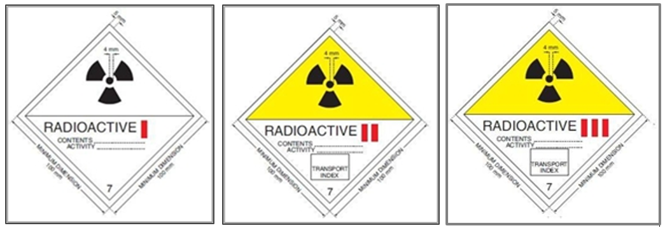
Figure 32
Radioactive hazard symbol used for radioactive material transport. From Radioactive hazard symbol, by the European Commission (n.d.), CC BY 4.0.

5.3.3.2 Contamination
Contamination is the presence of radioactive material on surfaces, clothing, skin, or within the body. It may occur due to the spillage of radiopharmaceuticals or biological fluids from patients (e.g., urine, vomit, blood).
Contamination may be classified as external, when radioactive material is present on the skin, clothing, or surfaces, or internal, when radioactive material enters the body.
The severity of contamination depends on several factors, including the radionuclide type and activity, the extent of spread, the number of individuals involved, and the radiotoxicity of the material (U.S. Department of Energy, 2012; Saha, 2019).
In the event of contamination (e.g., accidental release of radioactive material, such as radiopharmaceuticals or patient bodily fluids), the following actions should be taken:
- Avoid direct contact with the radioactive material
- Warn others and restrict access to the area
- Wear protective clothing and disposable gloves, if available
- Cover the spill with absorbent materials to prevent the spread of contamination
- Notify the Radiation Protection Officer (RPO) or nuclear medicine staff immediately, and follow their instructions
- In cases of severe contamination, ensure that decontamination is carried out under the supervision of the RPO

In case of personal contamination:
- If skin contamination occurs, the affected area should be washed immediately with non-abrasive soap and cold water
- If eye contamination occurs, the eye should be flushed immediately with large quantities of water
- Inform radiation protection personnel after initial decontamination (Saha, 2019; IAEA, 2018; IAEA, 2005)

5.3.3.3 Medical Emergencies
Life-threatening medical emergencies (e.g., cardiac arrest, stroke) involving radioactive patients must never be delayed due to radiation concerns. Emergency personnel should be appropriately trained in the management of radioactive patients. In such situations, the following precautions should be observed:
- Inform healthcare staff when a radioactive patient is admitted
- Wear impermeable protective gloves
- Avoid direct contact with bodily fluids
- Take precautions to prevent contamination
If the medical condition of a radioactive patient deteriorates and transfer to an intensive care unit or cardiac care unit is required, the RPO should be informed immediately to provide specific radiation protection instructions.
If urgent surgery is required, the RPO should also be informed immediately. Operating room personnel should:
- Be informed of the patient’s radioactive status
- Follow the instructions of the RPO, which may modify operating procedures to minimize exposure and the spread of contamination
- Wear appropriate protective equipment, provided that it does not compromise surgical performance
- Remain in the operating room only for the time necessary to perform their duties
- Be rotated if the surgical procedure is prolonged (IAEA, 2005; Dauer, 2014)

5.4 Radiotherapy
Radiotherapy is a medical specialty that uses high doses of ionizing radiation to treat cancer and, in some cases, non-malignant diseases. The objective is to deliver a therapeutic dose to the target tissue while minimizing exposure to surrounding healthy tissues. Two main categories are used: external beam radiotherapy and brachytherapy.
In external beam radiotherapy, radiation is delivered from outside the body using high-energy X-rays, gamma rays, electrons, or heavy charged particles. These beams are produced by specialized equipment such as linear accelerators or radioactive sources (e.g., cobalt-60).
In brachytherapy, small sealed radioactive sources are placed directly inside or near the tumor, allowing the delivery of high doses locally while reducing exposure to surrounding tissues (IAEA, 2018; Suntharalingam, 2005; ICRP, 2021).

5.4.1 Radiation Protection Measures in External Beam Therapy
Radiotherapy treatment rooms are controlled areas with restricted access, warning signs, and safety systems. Due to the high-energy beams used, no individual should be present in the treatment room during radiation delivery, except for the patient.
Safety systems such as interlocks are installed to immediately interrupt radiation delivery if necessary. Interlocks, located within the treatment room, allow manual interruption of the treatment machine in cases where someone has accidentally remained in the room during treatment delivery (IAEA, 2018).


Figure 33
The “panic” button.
From Oxford linac safety interlock system, by S. Gilchrist and B. Vojnovic (2012), University of Oxford. Licensed under CC BY-NC-ND 3.0.

Safety precautions:
- Follow instructions from radiotherapy staff
- Follow all warning signs and light signals
- Enter the treatment room only when authorized and instructed by radiotherapy staff

5.4.2 Radiation Protection Measures in Brachytherapy
Brachytherapy treatments are classified as permanent or temporary implantation techniques.
In permanent implantation, small radioactive sources remain in the target tissue and gradually decay over time.
In temporary implantation, radioactive sources are inserted for a defined period and subsequently removed. Temporary techniques include high-dose-rate (HDR) brachytherapy, in which the dose is delivered at a high rate over a short period (minutes); low-dose-rate (LDR) brachytherapy, in which the dose is delivered continuously at a low rate over a longer period (hours to days); and pulse-dose-rate (PDR) brachytherapy, in which the dose is delivered in periodic pulses to simulate continuous LDR treatment.
In HDR and PDR brachytherapy, patients are radioactive only during the treatment. In LDR brachytherapy, patients remain radioactive for the duration required for treatment (hours to days) and may be hospitalized in dedicated controlled areas,
Brachytherapy sources are typically very small and may be difficult to distinguish from common medical materials. Although rare, incidents such as displacement or loss of a radioactive source may occur, particularly in LDR treatments, and may lead to significant radiation exposure (IAEA, 2018; ICRP, 2021; Suntharalingam, 2005). Any unfamiliar object found near a brachytherapy patient (e.g., in bedding, clothing, or waste) should be treated as potentially radioactive. Contact should be avoided, and designated radiation protection personnel should be notified immediately.

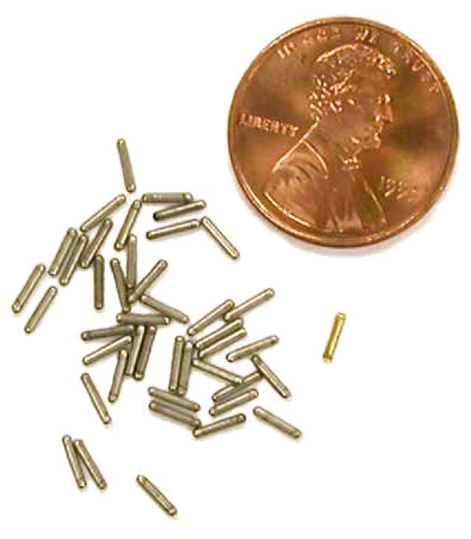
Figure 34
Radioactive seeds used in brachytherapy. From Radioactive seeds, by Nuclear Regulatory Commission (2012), Flickr. Licensed under CC BY 2.0.

Safety precautions:
- Follow instructions from radiotherapy staff
- Limit time spent near a radioactive patient
- Maintain distance whenever possible
- Do not touch or handle any unfamiliar objects near the patient
- Report any suspected radioactive object immediately

References

Alberts, B., Bray, D., Hopkin, K., Johnson, A. D., Lewis, J., Raff, M., Roberts, K., & Walter, P. (2013). Essential cell biology (4th ed.). Garland Science.
Aryee, G. F. B., Amoadu, M., Obeng, P., Sarkwah, H. N., Malcalm, E., Abraham, S. A., Baah, J. A., Agyare, D. F., Banafo, N. E., & Ogaji, D. (2024). Effectiveness of eLearning programme for capacity building of healthcare professionals: A systematic review. Human Resources for Health, 22, 60. https://doi.org/10.1186/s12960-024-00924-x
Baeyens, A., et al. (2023). Basic Concepts of Radiation Biology. In S. Baatout (Ed.), Radiobiology Textbook. Springer Cham. https://doi.org/10.1007/978-3-031-18810-7_2
Carlsson, S. T., & Le Heron, J. C. (2014). Radiation protection. In D.L. Bailey, J.L. Humm, A. Todd-Pokropek, & A. van Aswegen (Eds.), Nuclear medicine physics: A handbook for teachers and students. International Atomic Energy Agency. https://www.iaea.org/publications/10368/nuclear-medicine-physics
Cember, H., & Johnson, T. E. (2008). Introduction to health physics (4th ed.). McGraw-Hill.
Charmchi, R., Moradimajd, P., Saei, A., Paydar, R., & Abolghasemi, J. (2025). Comparison of the effectiveness of radiation protection principles training through multimedia and instructional booklet on the awareness of operating room staff. Journal of Education and Health Promotion, 14, 92. https://doi.org/10.4103/jehp.jehp_1885_23
Cherry, S. R., Sorenson, J. A., & Phelps, M. E. (2012). Physics in nuclear medicine (4th ed.). Elsevier.
Council of the European Union. (2013). Council Directive 2013/59/Euratom of 5 December 2013 laying down basic safety standards for protection against the dangers arising from exposure to ionising radiation. Official Journal of the European Union, L13, 1–73. https://eur-lex.europa.eu/eli/dir/2013/59/oj/eng
Dale, R.G., & Wondergem, J. (2014). Basic radiobiology. In D.L. Bailey, J.L. Humm, A. Todd-Pokropek, & A. van Aswegen (Eds.), Nuclear medicine physics: A handbook for teachers and students. International Atomic Energy Agency. https://www.iaea.org/publications/10368/nuclear-medicine-physics
Dauer, L.T. (2014). Management of therapy patients. In D.L. Bailey, J.L. Humm, A. Todd-Pokropek, & A. van Aswegen (Eds.), Nuclear medicine physics: A handbook for teachers and students. International Atomic Energy Agency. https://www.iaea.org/publications/10368/nuclear-medicine-physics
Dennisthemonkeychild. (2015). Mobile X-ray image intensifier [Photograph]. Wikimedia Commons.
https://commons.wikimedia.org/wiki/File:Mobile_X-ray_image_intensifier.JPG
European Commission. (2014). Guidelines on radiation protection education and training of medical professionals in the European Union (Radiation Protection Report No. 175). Publications Office of the European Union. https://doi.org/10.2833/19786
European Commission. (2014). Radiation protection no. 180: Medical radiation exposure of the European population (Part 1). Publications Office of the European Union. https://www.eurosafeimaging.org/wp/wp-content/uploads/2015/05/Radiation-Protection-180.pdf
European Commission. (n.d.). Radioactive hazard symbol [Image]. https://ec.europa.eu/taxation_customs/dds2/SAMANCTA/COMMON/HealthSafety/Graphics/Radioactive2.jpg
Flux, G., & Yong, D. (2014). Radionuclide therapy. In D.L. Bailey, J.L. Humm, A. Todd-Pokropek, & A. van Aswegen (Eds.), Nuclear medicine physics: A handbook for teachers and students. International Atomic Energy Agency. https://www.iaea.org/publications/10368/nuclear-medicine-physics
Gilchrist, S., & Vojnovic, B. (2012). Oxford linac safety interlock system [Photograph]. University of Oxford. https://users.ox.ac.uk/~atdgroup/technicalnotes/Oxford%20linac%20safety%20interlock%20system.pdf
Greek Atomic Energy Commission (EEAE). (2023). Κατευθυντήριες οδηγίες για προγράμματα εκπαίδευσης, πληροφόρησης και κατάρτισης στην ακτινοπροστασία για πρακτικές που περιλαμβάνουν ιατρική έκθεση (Μη ιατρικό προσωπικό) [Guidelines for training, information, and education programs in radiation protection for practices involving medical exposure (Non-medical staff)] (KA-EEAE-KO-062019-01, Rev. 2). https://eeae.gr/files/KO/KA-EEAE-KO-062019-01.pdf (in Greek)
Greek Atomic Energy Commission. (n.d.). About EEAE. https://www.eeae.gr
Hosny, T., Al-Anezi, E., & Khalil, M. M. (2017). Basic radiation physics. In M. M. Khalil (Ed.), Basic science of PET imaging. Springer. https://doi.org/10.1007/978-3-319-40070-9_1
Huda, W. (2010). Review of radiologic physics (3rd ed.). Lippincott Williams & Wilkins.
International Atomic Energy Agency. (2005). Applying radiation safety standards in nuclear medicine (Safety Reports Series No. 40, STI/PUB/1207). IAEA. https://www-pub.iaea.org/MTCD/Publications/PDF/Pub1207_web.pdf
International Atomic Energy Agency. (2009). Release of patients after radionuclide therapy (Safety Reports Series No. 63). IAEA. https://www.iaea.org/publications/8179/release-of-patients-after-radionuclide-therapy
International Atomic Energy Agency. (2010). Radiation biology: A handbook for teachers and students (Training Course Series No. 42). IAEA. https://www-pub.iaea.org/MTCD/Publications/PDF/TCS-42_web.pdf
International Atomic Energy Agency. (2014). Radiation protection and safety of radiation sources: International basic safety standards (General Safety Requirements Part 3). IAEA. https://www.iaea.org/publications/8736/radiation-protection-and-safety-of-radiation-sources-international-basic-safety-standards?utm_source=chatgpt.com
International Atomic Energy Agency. (2018). Radiation protection and safety in medical uses of ionizing radiation (IAEA Safety Standards Series No. SSG-46). IAEA. https://www.iaea.org/publications/11102/radiation-protection-and-safety-in-medical-uses-of-ionizing-radiation
International Commission on Radiological Protection. (2007). The 2007 recommendations of the International Commission on Radiological Protection ICRP Publication 103. Ann. ICRP, 37(2–4). https://www.icrp.org/publication.asp?id=ICRP%20Publication%20103
International Commission on Radiological Protection. (2013). Radiological protection in paediatric diagnostic and interventional radiology. ICRP Publication 121. Ann. ICRP 42(2). https://www.icrp.org/publication.asp?id=icrp%20publication%20121
International Commission on Radiological Protection. (2019). Radiological protection in therapy with radiopharmaceuticals. ICRP Publication 140. Ann. ICRP 48(1). https://www.icrp.org/publication.asp?id=ICRP%20Publication%20140
International Commission on Radiological Protection. (2021). Occupational radiological protection in brachytherapy. ICRP Publication 149. Ann. ICRP 50(1). https://doi.org/10.1177/01466453211066467
Joiner, M. C. (2009). Cell death after irradiation – how, when and why cells die. In M. Joiner & A. van der Kogel (Eds.), Basic clinical radiobiology (4th ed.) . Hodder Arnold.
Joint Ministerial Decision 32083/2022. (2022). Τροποποίηση της υπ’ αρ. 45872/26.3.2019 κοινής υπουργικής απόφασης «Διαδικασίες κανονιστικού ελέγχου πρακτικών ιοντιζουσών ακτινοβολιών – αναγνώριση υπηρεσιών και εμπειρογνωμόνων» [Amendment of Joint Ministerial Decision 45872/26.3.2019 “Procedures for regulatory control of ionizing radiation practices – recognition of services and experts”] (Government Gazette 1552/B’). https://eeae.gr/files/nomothesia/%CE%A6%CE%95%CE%9A_%CE%92_1552.pdf (in Greek)
Joint Ministerial Decision 45872/2019. (2019). Διαδικασίες κανονιστικού ελέγχου πρακτικών ιοντιζουσών ακτινοβολιών – αναγνώριση υπηρεσιών και εμπειρογνωμόνων [Procedures for regulatory control of ionizing radiation practices – recognition of services and experts] (Government Gazette 1103/B’). https://eeae.gr/files/nomothesia/YA_FEK_1103_03_04_2019.pdf (in Greek)
Joint Research Centre, European Commission. (2024). Simplified pathways of natural radionuclides [Image]. Licensed under CC-BY-4.0. https://joint-research-centre.ec.europa.eu/sites/default/files/styles/oe_theme_medium_no_crop/public/2024-09/Simplified%20pathways%20of%20natural%20radionuclides.jpg?itok=Z0OhKE3a
Juhele. (2017). Penetrating power of different types of radiation – alpha, beta, gamma and neutrons [Illustration]. Wikimedia Commons. https://commons.wikimedia.org/wiki/File:Penetrating_power_of_different_types_of_radiation_-_alpha,_beta,_gamma_and_neutrons.svg
Kiran891. (2023, March 16). Darby X-Ray apron [Photograph]. Wikimedia Commons. https://commons.wikimedia.org/wiki/File:Darby_X-Ray_apron_20230316_105852.jpg
Lodge, M.A., & Frey, E.C. (2014). Nuclear medicine imaging devices. In D.L. Bailey, J.L. Humm, A. Todd-Pokropek, & A. van Aswegen (Eds.), Nuclear medicine physics: A handbook for teachers and students. International Atomic Energy Agency. https://www.iaea.org/publications/10368/nuclear-medicine-physics
Magladem96. (2014). DNA base flipping [Image]. Wikimedia Commons. https://commons.wikimedia.org/wiki/File:Dna-base-flipping.svg
Maqbool, M. (2017). Introduction. In M. Maqbool (Ed.), An introduction to medical physics. Springer Cham. https://doi.org/10.1007/978-3-319-61540-0_1
MaxxL. (2013, June 5). ISO 7010 W003: Radioactive material or ionizing radiation [Public domain image]. Wikimedia Commons. https://upload.wikimedia.org/wikipedia/commons/thumb/a/a8/ISO_7010_W003.svg/960px-ISO_7010_W003.svg.png?20230804201000
Morissette, A. (2007). Mutation.JPG [JPEG image]. Wikimedia Commons. https://commons.wikimedia.org/wiki/File:Mutation.JPG
Ng, K.-H., & Dance, D. R. (2014). Introduction to diagnostic radiology physics. In D. R. Dance, S. Christofides, A. D. A. Maidment, I. D. McLean, & K.-H. Ng (Eds.), Diagnostic radiology physics: A handbook for teachers and students. International Atomic Energy Agency. https://www.iaea.org/publications/8841/diagnostic-radiology-physics
Nowotny, R. (2014). X ray production. In D. R. Dance, S. Christofides, A. D. A. Maidment, I. D. McLean, & K.-H. Ng (Eds.), Diagnostic radiology physics: A handbook for teachers and students. International Atomic Energy Agency. https://www.iaea.org/publications/8841/diagnostic-radiology-physics
Nuclear Regulatory Commission. (2012). Radioactive seeds [Photograph]. Flickr. https://www.flickr.com/photos/nrcgov/7845754328/
Panda, A.K., Parashar, M. (2022). The Effectiveness of Online Learning Platforms in Healthcare Education: A Meta-Analysis. Health Leadership and Quality of Life. 1,116. https://doi.org/10.56294/hl2022116
Podgoršak, E. B. (2016). Radiation physics for medical physicists (3rd ed.). Springer. https://doi.org/10.1007/978-3-319-25382-4
Podgorsak, E.B., Kesner, A.L., & Soni, P.S. (2014). Basic physics for nuclear medicine. In D.L. Bailey, J.L. Humm, A. Todd-Pokropek, & A. van Aswegen (Eds.), Nuclear medicine physics: A handbook for teachers and students. International Atomic Energy Agency. https://www.iaea.org/publications/10368/nuclear-medicine-physics
Poletti, J.L. (2014) Projection radiography. In D. R. Dance, S. Christofides, A. D. A. Maidment, I. D. McLean, & K.-H. Ng (Eds.), Diagnostic radiology physics: A handbook for teachers and students. International Atomic Energy Agency. https://www.iaea.org/publications/8841/diagnostic-radiology-physics
Presidential Decree 101/2018. (2018). Προσαρμογή της ελληνικής νομοθεσίας στην Οδηγία 2013/59/Ευρατόμ του Συμβουλίου, της 5ης Δεκεμβρίου 2013 [Adaptation of Greek legislation to Council Directive 2013/59/Euratom of 5 December 2013] (Government Gazette 194/A’). https://eeae.gr/files/nomothesia/298.FEK_194_A_PD_101_20.11.2018.pdf (in Greek)
Reindl, J., et al. (2023). Molecular Radiation Biology. In S. Baatout (Ed.), Radiobiology Textbook. Springer Cham. https://doi.org/10.1007/978-3-031-18810-7_3
Saha, G. B. (2019). Radiation safety in nuclear medicine. Springer. https://doi.org/10.1007/978-3-030-16406-5
Sinclair, P.M., Kable, A., Levett-Jones, & T., Booth D. (2016). The effectiveness of Internet-based e-learning on clinician behaviour and patient outcomes: A systematic review. International Journal of Nursing Studies, 57, 70–81. https://doi.org/10.1016/j.ijnurstu.2016.01.011
Sminia, P., et al. (2023). Clinical Radiobiology for Radiation Oncology. In S. Baatout (Ed.), Radiobiology Textbook. Springer Cham. https://doi.org/10.1007/978-3-031-18810-7_5
Spazturtle. (2015). EM-spectrum.svg [Diagram]. Wikimedia Commons. https://commons.wikimedia.org/wiki/File:EM-spectrum.svg
Suntharalingam, N., Podgorsak, E. B., & Hendry, J. H. (2005). Basic radiobiology. In E. B. Podgorsak (Ed.), Radiation oncology physics: A handbook for teachers and students. International Atomic Energy Agency. https://www.iaea.org/publications/7086/radiation-oncology-physics
Suntharalingam, N., Podgorsak, E. B., & Tolli, H. (2005). Brachytherapy: physical and clinical aspects. In E. B. Podgorsak (Ed.), Radiation oncology physics: A handbook for teachers and students. International Atomic Energy Agency. https://www.iaea.org/publications/7086/radiation-oncology-physics
SuperManu. (2007). Onde_electromagnetique.svg [Diagram]. Wikimedia Commons. https://commons.wikimedia.org/wiki/File:Onde_electromagnetique.svg
(Original work modified by the author.)
Sutton, D., Collins, L. T. & Le Heron, J. (2014). Radiation protection. In D. R. Dance, S. Christofides, A. D. A. Maidment, I. D. McLean, & K.-H. Ng (Eds.), Diagnostic radiology physics: A handbook for teachers and students. International Atomic Energy Agency. https://www.iaea.org/publications/8841/diagnostic-radiology-physics
Syced. (2022). Mobile X-Ray Unit Sirius Star Mobile [Photograph]. Wikimedia Commons. https://commons.wikimedia.org/wiki/File:Mobile_X-Ray_Unit_Sirius_Star_Mobile.jpg
U.S. Department of Energy. (2012). Radioactive materials transportation and incident response: Q&A about incident response. https://www.energy.gov/sites/prod/files/em/TEPP/RadioactiveMaterialTransportationandIncidentResponse-QABook.pdf
U.S. Environmental Protection Agency. (2018). Penetrating powers of ionizing radiation image [Image]. https://www.epa.gov/sites/production/files/2018-12/documents/penetrating-powers-of-ionizing-radiation-image-re3.pdf
U.S. Nuclear Regulatory Commission. (n.d.). Time, distance, and shielding [Image]. U.S. Nuclear Regulatory Commission. https://www.nrc.gov/sites/default/files/doc_library/cdn/legacy/images/about-nrc/radiation/time-distance-shielding.gif
United Nations Environment Programme. (2016). Radiation: Effects and sources. United Nations Environment Programme. https://wedocs.unep.org/items/10058dfa-780f-4472-82be-463363c30f7a
United Nations Scientific Committee on the Effects of Atomic Radiation. (2008). Sources and effects of ionizing radiation (Report to the General Assembly, with scientific annexes). United Nations. https://www.unscear.org/unscear/en/publications/2008_1.html
VectorPortal. (n.d.). Radioactive symbol [Vector image]. https://vectorportal.com/storage/radioact1_7020.jpg
Wellcome Library. (n.d.). Photograph of a radiograph of hand taken by Wilhelm Conrad R [Photograph]. Wikimedia Commons. Licensed under CC BY 4.0. https://commons.wikimedia.org/wiki/File:Photograph_of_a_radiograph_of_hand_taken_by_Wilhelm_Conrad_R_Wellcome_L0058010.jpg
Wilson-Stewart, K., Shanahan, M., Fontanarosa, D., & Davidson, R. (2018). Lead protection and staff position [Diagram]. Wikimedia Commons. https://commons.wikimedia.org/wiki/File:Lead_protection_and_staff_position.jpg
Wondergem, J. (2014). Radiation biology. In D. R. Dance, S. Christofides, A. D. A. Maidment, I. D. McLean, & K.-H. Ng (Eds.), Diagnostic radiology physics: A handbook for teachers and students. International Atomic Energy Agency. https://www.iaea.org/publications/8841/diagnostic-radiology-physics

